

**Project :** VikyGym, a local fitness and wellness center

# Deploy a **Static Website** using Microsoft azure **Virtual Machine** and apply **Application gateway (Load balancer ).**

**Team Members :**

1. Vivek Mane
2. Harshal Sonawane
3. Ajit Misal

**Case Study**: Deploying VikyGym Static Website on Azure

**Overview**:

**Project Name**: VikyGym Static Website Deployment on Azure

**Client**: VikyGym, a local fitness and wellness center

**Introduction**:

VikyGym, a thriving fitness and wellness center nestled in the heart of a bustling urban area, recognized the significance of extending their reach beyond their physical location. They understood that establishing an online presence was essential for reaching a wider audience and providing prospective clients with comprehensive information about their services and facilities. In collaboration with our team of Azure experts, VikyGym embarked on a transformative journey to deploy their static website on the Azure cloud platform.

**Challenges**:

VikyGym faced several challenges, including:

**Lack of Online Presence:** The absence of a website limited their ability to connect with potential clients who primarily search for fitness centers and services online.

**Accessibility:** They needed to ensure that their website was accessible to users on various devices and from different locations.

**Performance**: It was crucial to optimize the website for speed and reliability to provide a seamless and engaging user experience.

**Cost Efficiency:** VikyGym needed a solution that aligned with their budget while providing scalability and reliability.

**Solution : (Services Used )**

**Azure VM :** Azure Virtual Machines (VM): To provide enhanced functionality and dynamic content on their website, VikyGym opted for Azure VMs. These virtual machines allowed them to run specific applications and services that required server-side processing. By deploying VMs, VikyGym could execute custom code, process user data, and offer interactive features on their website, such as appointment booking, membership registration, and real-time class schedules. Azure VMs ensured flexibility, scalability, and the ability to tailor their web applications to their unique requirements.

IIS Web Server: We deployed Azure Virtual Machines to host the IIS (Internet Information Services) web server. This allowed us to run VikyGym's website application efficiently and provided full control over the hosting environment.

**Azure Application Gateway**: Azure Application Gateway was implemented to act as a web traffic load balancer, distributing incoming requests to the Azure VMs. This load balancing mechanism helped optimize website performance, ensuring that traffic was efficiently distributed to maintain responsiveness.

**Azure DNS (Default Azure Domain):** We used Azure DNS, including default Azure domain services, to manage domain names, configure DNS records, and route traffic to the appropriate Azure resources. This service played a vital role in ensuring that VikyGym's custom domain was correctly associated with their website hosted on Azure VMs and Application Gateway.

By combining these Azure services, we were able to create a robust and scalable infrastructure for VikyGym's website, delivering an engaging online experience for their clients and potential customers. This integrated solution ensured that the website was not only visually appealing but also highly performant and accessible, meeting VikyGym's goals of expanding their online reach and providing essential information about their services and facilities.

**Results**:

This comprehensive Azure-based solution yielded the following results for VikyGym:

**Online Presence:** VikyGym successfully established a robust online presence, allowing them to connect with a wider audience and provide detailed information about their fitness and wellness services.

**Accessibility:** With Azure services, the website was accessible from various devices and locations, catering to a diverse user base.

**Performance Optimization:** Utilizing Azure VMs and load balancing with Azure Application Gateway, the website's performance was significantly improved, ensuring a smooth and responsive user experience.

**Custom Domain:** The use of Azure DNS facilitated the seamless mapping of the custom domain to the Azure VM instances, reinforcing the brand identity.

**VikyGym, a local fitness and wellness center Source Code Is given By :**

<!DOCTYPE html>

<html lang="en">

  <head>

    <meta charset="utf-8">

    <meta name="viewport" content="width=device-width, initial-scale=1, shrink-to-fit=no">

    <meta name="description" content="">

    <meta name="author" content="">

    <link href="https://fonts.googleapis.com/css?family=Poppins:100,100i,200,200i,300,300i,400,400i,500,500i,600,600i,700,700i,800,800i,900,900i&display=swap" rel="stylesheet">

    <title>Gym - Free CSS Template</title>

<!--

TemplateMo 548 Training Studio

https://templatemo.com/tm-548-training-studio

-->

    <!-- Additional CSS Files -->

    <link rel="stylesheet" type="text/css" href="assets/css/bootstrap.min.css">

    <link rel="stylesheet" type="text/css" href="assets/css/font-awesome.css">

    <link rel="stylesheet" href="assets/css/templatemo-training-studio.css">

    </head>

    <body>

    <!-- ***** Preloader Start ***** -->

    <div id="js-preloader" class="js-preloader">

      <div class="preloader-inner">

        <span class="dot"></span>

        <div class="dots">

          <span></span>

          <span></span>

          <span></span>

        </div>

      </div>

    </div>

    <!-- ***** Preloader End ***** -->

    <!-- ***** Header Area Start ***** -->

    <header class="header-area header-sticky">

        <div class="container">

            <div class="row">

                <div class="col-12">

                    <nav class="main-nav">

                        <!-- ***** Logo Start ***** -->

                        <a href="index.html" class="logo">Viky<em> Gym</em></a>

                        <!-- ***** Logo End ***** -->

                        <!-- ***** Menu Start ***** -->

                        <ul class="nav">

                            <li class="scroll-to-section"><a href="#top" class="active">Home</a></li>

                            <li class="scroll-to-section"><a href="#features">About</a></li>

                            <li class="scroll-to-section"><a href="#our-classes">Classes</a></li>

                            <li class="scroll-to-section"><a href="#schedule">Schedules</a></li>

                            <li class="scroll-to-section"><a href="#contact-us">Contact</a></li>

                            <li class="main-button"><a href="#">Sign Up</a></li>

                        </ul>

                        <a class='menu-trigger'>

                            <span>Menu</span>

                        </a>

                        <!-- ***** Menu End ***** -->

                    </nav>

                </div>

            </div>

        </div>

    </header>

    <!-- ***** Header Area End ***** -->

    <!-- ***** Main Banner Area Start ***** -->

    <div class="main-banner" id="top">

        <video autoplay muted loop id="bg-video">

            <source src="assets/images/Boxing.mp4" type="video/mp4" />

        </video>

        <div class="video-overlay header-text">

            <div class="caption">

                <h6>work harder, get stronger</h6>

                <h2>easy with our <em>Viky gym</em></h2>

                <div class="main-button scroll-to-section">

                    <a href="#features">Become a member</a>

                </div>

            </div>

        </div>

    </div>

    <!-- ***** Main Banner Area End ***** -->

    <!-- ***** Features Item Start ***** -->

    <section class="section" id="features">

        <div class="container">

            <div class="row">

                <div class="col-lg-6 offset-lg-3">

                    <div class="section-heading">

                        <h2>Choose <em>Program</em></h2>

                        <img src="assets/images/line-dec.png" alt="waves">

                        <p>"Viky Gym is a fitness center known for its friendly community, state-of-the-art equipment, and expert trainers. Whether you're a beginner or an experienced athlete, we're here to help you achieve your fitness goals. Join us for a healthier, happier you!"</p>

                    </div>

                </div>

                <div class="col-lg-6">

                    <ul class="features-items">

                        <li class="feature-item">

                            <div class="left-icon">

                                <img src="assets/images/features-first-icon.png" alt="First One">

                            </div>

                            <div class="right-content">

                                <h4>Basic Fitness</h4>

                                <p>Cardiovascular Exercise, Bodyweight Strength Training, Flexibility and Stretching, Rest and Recovery, Balanced Diet</p>

                                <a href="#" class="text-button">Discover More</a>

                            </div>

                        </li>

                        <li class="feature-item">

                            <div class="left-icon">

                                <img src="assets/images/features-first-icon.png" alt="second one">

                            </div>

                            <div class="right-content">

                                <h4>New Gym Training</h4>

                                <p>

                                    Starting a new gym training routine is an exciting opportunity to work on your fitness goals, whether it's building muscle, improving cardiovascular endurance, or enhancing overall strength.</p>

                                <a href="#" class="text-button">Discover More</a>

                            </div>

                        </li>

                        <li class="feature-item">

                            <div class="left-icon">

                                <img src="assets/images/features-first-icon.png" alt="third gym training">

                            </div>

                            <div class="right-content">

                                <h4>Basic Muscle Course</h4>

                                <p>A basic muscle-building course is designed for beginners looking to develop strength and muscle through foundational exercises and techniques.</p>

                                <a href="#" class="text-button">Discover More</a>

                            </div>

                        </li>

                    </ul>

                </div>

                <div class="col-lg-6">

                    <ul class="features-items">

                        <li class="feature-item">

                            <div class="left-icon">

                                <img src="assets/images/features-first-icon.png" alt="fourth muscle">

                            </div>

                            <div class="right-content">

                                <h4>Advanced Muscle Course</h4>

                                <p>Periodization, Advanced Resistance Training, Strength and Hypertrophy Focus, Nutrition and Die, Recovery Strategies, Supplement Guidance, Tracking and Progression.</p>

                                <a href="#" class="text-button">Discover More</a>

                            </div>

                        </li>

                        <li class="feature-item">

                            <div class="left-icon">

                                <img src="assets/images/features-first-icon.png" alt="training fifth">

                            </div>

                            <div class="right-content">

                                <h4>Yoga Training</h4>

                                <p>Yoga training offers a holistic and mindful approach to physical and mental well-being, promoting flexibility, strength, relaxation, and stress reduction.</p>

                                <a href="#" class="text-button">Discover More</a>

                            </div>

                        </li>

                        <li class="feature-item">

                            <div class="left-icon">

                                <img src="assets/images/features-first-icon.png" alt="gym training">

                            </div>

                            <div class="right-content">

                                <h4>Body Building Course</h4>

                                <p>A bodybuilding course is a structured program that focuses on intense resistance training, nutrition, and supplementation to help individuals build significant muscle mass, strength, and achieve a sculpted physique.</p>

                                <a href="#" class="text-button">Discover More</a>

                            </div>

                        </li>

                    </ul>

                </div>

            </div>

        </div>

    </section>

    <!-- ***** Features Item End ***** -->

    <!-- ***** Call to Action Start ***** -->

    <section class="section" id="call-to-action">

        <div class="container">

            <div class="row">

                <div class="col-lg-10 offset-lg-1">

                    <div class="cta-content">

                        <h2>Don’t <em>think</em>, begin <em>today</em>!</h2>

                        <p>Embrace the present moment and take the first step towards your dreams with unwavering determination - today is the day to ignite your journey to success.</p>

                        <div class="main-button scroll-to-section">

                            <a href="#our-classes">Become a member</a>

                        </div>

                    </div>

                </div>

            </div>

        </div>

    </section>

    <!-- ***** Call to Action End ***** -->

    <!-- ***** Our Classes Start ***** -->

    <section class="section" id="our-classes">

        <div class="container">

            <div class="row">

                <div class="col-lg-6 offset-lg-3">

                    <div class="section-heading">

                        <h2>Our <em>Classes</em></h2>

                        <img src="assets/images/line-dec.png" alt="">

                        <p>OUR CLASSES

                            Now, an urn is empty, filled with the high seats of abundant provision. The living essence is pain, the ferment of might is the suitable provision.</p>

                    </div>

                </div>

            </div>

            <div class="row" id="tabs">

              <div class="col-lg-4">

                <ul>

                  <li><a href='#tabs-1'><img src="assets/images/tabs-first-icon.png" alt="">First Training Class</a></li>

                  <li><a href='#tabs-2'><img src="assets/images/tabs-first-icon.png" alt="">Second Training Class</a></a></li>

                  <li><a href='#tabs-3'><img src="assets/images/tabs-first-icon.png" alt="">Third Training Class</a></a></li>

                  <li><a href='#tabs-4'><img src="assets/images/tabs-first-icon.png" alt="">Fourth Training Class</a></a></li>

                  <div class="main-rounded-button"><a href="#">View All Schedules</a></div>

                </ul>

              </div>

              <div class="col-lg-8">

                <section class='tabs-content'>

                  <article id='tabs-1'>

                    <img src="assets/images/training-image-01.jpg" alt="First Class">

                    <h4>First Training Class</h4>

                    <p>

                        "Welcome to our 'First Training Class,' where fitness begins! Whether you're new to exercise or looking to restart your fitness journey, this class is the perfect entry point. Our experienced trainers will provide personalized guidance, helping you learn the fundamentals of exercise and kickstart your path to a healthier lifestyle."</p>

                    <div class="main-button">

                        <a href="#">View Schedule</a>

                    </div>

                  </article>

                  <article id='tabs-2'>

                    <img src="assets/images/training-image-02.jpg" alt="Second Training">

                    <h4>Second Training Class</h4>

                    <p>"Step into our 'Second Training Class,' the next phase of your fitness journey. Building on the foundations of the first class, this program introduces more advanced exercises and challenges, helping you further enhance your strength and endurance.

                        Our experienced trainers will continue to provide expert guidance and motivation, ensuring you reach your fitness goals. It's a natural progression in your quest for a healthier, more energetic lifestyle. Join us and take the next step towards your fitness success."</p>

                    <div class="main-button">

                        <a href="#">View Schedule</a>

                    </div>

                  </article>

                  <article id='tabs-3'>

                    <img src="assets/images/training-image-03.jpg" alt="Third Class">

                    <h4>Third Training Class</h4>

                    <p>"Welcome to our 'Third Training Class,' the next step in your fitness journey. Building on the foundation from your previous sessions, this class offers more advanced workouts and techniques to further enhance your strength and stamina.

                        Our expert trainers will challenge you to push your limits, helping you achieve new fitness milestones. Whether you're aiming to build muscle, increase endurance, or improve overall fitness, this class is designed to support your evolving goals.

                        Join us and continue on your path to a healthier and more confident you. It's time to embrace the third stage of your fitness transformation!"</p>

                    <div class="main-button">

                        <a href="#">View Schedule</a>

                    </div>

                  </article>

                  <article id='tabs-4'>

                    <img src="assets/images/training-image-04.jpg" alt="Fourth Training">

                    <h4>Fourth Training Class</h4>

                    <p>"Welcome to our 'Fourth Training Class,' where your fitness journey continues to evolve. In this intermediate-level class, we build on the foundation you've already established, focusing on advanced techniques and greater challenges to further enhance your strength and stamina.

                        Our experienced trainers will guide you through a range of exercises, ensuring that you progress towards your fitness goals. This class is designed for those who are ready to take their fitness to the next level and continue their path to a healthier, fitter lifestyle.

                        Join us for the 'Fourth Training Class' and experience the thrill of pushing your limits and achieving new milestones in your fitness journey."</p>

                    <div class="main-button">

                        <a href="#">View Schedule</a>

                    </div>

                  </article>

                </section>

              </div>

            </div>

        </div>

    </section>

    <!-- ***** Our Classes End ***** -->

    <section class="section" id="schedule">

        <div class="container">

            <div class="row">

                <div class="col-lg-6 offset-lg-3">

                    <div class="section-heading dark-bg">

                        <h2>Classes <em>Schedule</em></h2>

                        <img src="assets/images/line-dec.png" alt="">

                        <p>Nunc urna sem, laoreet ut metus id, aliquet consequat magna. Sed viverra ipsum dolor, ultricies fermentum massa consequat eu.</p>

                    </div>

                </div>

            </div>

            <div class="row">

                <div class="col-lg-12">

                    <div class="filters">

                        <ul class="schedule-filter">

                            <li class="active" data-tsfilter="monday">Monday</li>

                            <li data-tsfilter="tuesday">Tuesday</li>

                            <li data-tsfilter="wednesday">Wednesday</li>

                            <li data-tsfilter="thursday">Thursday</li>

                            <li data-tsfilter="friday">Friday</li>

                        </ul>

                    </div>

                </div>

                <div class="col-lg-10 offset-lg-1">

                    <div class="schedule-table filtering">

                        <table>

                            <tbody>

                                <tr>

                                    <td class="day-time">Fitness Class</td>

                                    <td class="monday ts-item show" data-tsmeta="monday">10:00AM - 11:30AM</td>

                                    <td class="tuesday ts-item" data-tsmeta="tuesday">2:00PM - 3:30PM</td>

                                    <td>Bhumiket Ahire</td>

                                </tr>

                                <tr>

                                    <td class="day-time">Muscle Training</td>

                                    <td class="friday ts-item" data-tsmeta="friday">10:00AM - 11:30AM</td>

                                    <td class="thursday friday ts-item" data-tsmeta="thursday" data-tsmeta="friday">2:00PM - 3:30PM</td>

                                    <td>Harshal Sonawane</td>

                                </tr>

                                <tr>

                                    <td class="day-time">Body Building</td>

                                    <td class="tuesday ts-item" data-tsmeta="tuesday">10:00AM - 11:30AM</td>

                                    <td class="monday ts-item show" data-tsmeta="monday">2:00PM - 3:30PM</td>

                                    <td>Sarth Mane</td>

                                </tr>

                                <tr>

                                    <td class="day-time">Yoga Training Class</td>

                                    <td class="wednesday ts-item" data-tsmeta="wednesday">10:00AM - 11:30AM</td>

                                    <td class="friday ts-item" data-tsmeta="friday">2:00PM - 3:30PM</td>

                                    <td>Ajit Misal</td>

                                </tr>

                                <tr>

                                    <td class="day-time">Advanced Training</td>

                                    <td class="thursday ts-item" data-tsmeta="thursday">10:00AM - 11:30AM</td>

                                    <td class="wednesday ts-item" data-tsmeta="wednesday">2:00PM - 3:30PM</td>

                                    <td>Vivek Mane</td>

                                </tr>

                            </tbody>

                        </table>

                    </div>

                </div>

            </div>

        </div>

    </section>

    <!-- ***** Testimonials Starts ***** -->

    <section class="section" id="trainers">

        <div class="container">

            <div class="row">

                <div class="col-lg-6 offset-lg-3">

                    <div class="section-heading">

                        <h2>Expert <em>Trainers</em></h2>

                        <img src="assets/images/line-dec.png" alt="">

                        <p>Vivek Mane, Ajit Misal, Harshal Sonawane, Sarth Mane, Bhumiket Ahire.</p>

                    </div>

                </div>

            </div>

            <div class="row">

                <div class="col-lg-4">

                    <div class="trainer-item">

                        <div class="image-thumb">

                            <img src="assets/images/first-trainer.jpg" alt="">

                        </div>

                        <div class="down-content">

                            <span>Strength Trainer</span>

                            <h4>Vivek Mane</h4>

                            <p>Vivek Mane is an experienced and dedicated strength trainer, helping clients achieve their fitness goals through personalized training programs and expert guidance. His passion for strength training and commitment to fitness is evident in his successful track record of helping individuals build strength and transform their bodies.</p>

                            <ul class="social-icons">

                                <li><a href="#"><i class="fa fa-facebook"></i></a></li>

                                <li><a href="#"><i class="fa fa-twitter"></i></a></li>

                                <li><a href="#"><i class="fa fa-linkedin"></i></a></li>

                                <li><a href="#"><i class="fa fa-behance"></i></a></li>

                            </ul>

                        </div>

                    </div>

                </div>

                <div class="col-lg-4">

                    <div class="trainer-item">

                        <div class="image-thumb">

                            <img src="assets/images/second-trainer.jpg" alt="">

                        </div>

                        <div class="down-content">

                            <span>Muscle Trainer</span>

                            <h4>Ajit Misal</h4>

                            <p>Ajit Misal is a dedicated muscle trainer known for his expertise in guiding clients to achieve their muscle-building goals through tailored training and nutrition plans. With a passion for fitness and a focus on muscle development, he empowers individuals to reach their peak physical potential.</p>

                            <ul class="social-icons">

                                <li><a href="#"><i class="fa fa-facebook"></i></a></li>

                                <li><a href="#"><i class="fa fa-twitter"></i></a></li>

                                <li><a href="#"><i class="fa fa-linkedin"></i></a></li>

                                <li><a href="#"><i class="fa fa-behance"></i></a></li>

                            </ul>

                        </div>

                    </div>

                </div>

                <div class="col-lg-4">

                    <div class="trainer-item">

                        <div class="image-thumb">

                            <img src="assets/images/third-trainer.jpg" alt="">

                        </div>

                        <div class="down-content">

                            <span>Power Trainer</span>

                            <h4>Harshal Sonawane</h4>

                            <p>Harshal Sonawane is a seasoned power trainer renowned for his mastery in helping individuals build exceptional strength and explosive power through specialized training techniques and customized programs. With a dedication to pushing physical limits, he empowers clients to achieve their peak performance goals.</p>

                            <ul class="social-icons">

                                <li><a href="#"><i class="fa fa-facebook"></i></a></li>

                                <li><a href="#"><i class="fa fa-twitter"></i></a></li>

                                <li><a href="#"><i class="fa fa-linkedin"></i></a></li>

                                <li><a href="#"><i class="fa fa-behance"></i></a></li>

                            </ul>

                        </div>

                    </div>

                </div>

            </div>

        </div>

    </section>

    <!-- ***** Testimonials Ends ***** -->

    <!-- ***** Contact Us Area Starts ***** -->

    <section class="section" id="contact-us">

        <div class="container-fluid">

            <div class="row">

                <div class="col-lg-6 col-md-6 col-xs-12">

                    <div id="map">

                      <iframe src="https://maps.google.com/maps?q=Av.+L%C3%BAcio+Costa,+Rio+de+Janeiro+-+RJ,+Brazil&t=&z=13&ie=UTF8&iwloc=&output=embed" width="100%" height="600px" frameborder="0" style="border:0" allowfullscreen></iframe>

                    </div>

                </div>

                <div class="col-lg-6 col-md-6 col-xs-12">

                    <div class="contact-form">

                        <form id="contact" action="" method="post">

                          <div class="row">

                            <div class="col-md-6 col-sm-12">

                              <fieldset>

                                <input name="name" type="text" id="name" placeholder="Your Name*" required="">

                              </fieldset>

                            </div>

                            <div class="col-md-6 col-sm-12">

                              <fieldset>

                                <input name="email" type="text" id="email" pattern="[^ @]*@[^ @]*" placeholder="Your Email*" required="">

                              </fieldset>

                            </div>

                            <div class="col-md-12 col-sm-12">

                              <fieldset>

                                <input name="subject" type="text" id="subject" placeholder="Subject">

                              </fieldset>

                            </div>

                            <div class="col-lg-12">

                              <fieldset>

                                <textarea name="message" rows="6" id="message" placeholder="Message" required=""></textarea>

                              </fieldset>

                            </div>

                            <div class="col-lg-12">

                              <fieldset>

                                <button type="submit" id="form-submit" class="main-button">Send Message</button>

                              </fieldset>

                            </div>

                          </div>

                        </form>

                    </div>

                </div>

            </div>

        </div>

    </section>

    <!-- ***** Contact Us Area Ends ***** -->

    <!-- ***** Footer Start ***** -->

    <footer>

        <div class="container">

            <div class="row">

                <div class="col-lg-12">

                    <p>Copyright &copy; 2023

                    - Designed by 'Vivek Mane'

                Distributed by "Vivek Mane"

                </p>

                    <!-- You shall support us a little via PayPal to info@templatemo.com -->

                </div>

            </div>

        </div>

    </footer>

    <!-- jQuery -->

    <script src="assets/js/jquery-2.1.0.min.js"></script>

    <!-- Bootstrap -->

    <script src="assets/js/popper.js"></script>

    <script src="assets/js/bootstrap.min.js"></script>

    <!-- Plugins -->

    <script src="assets/js/scrollreveal.min.js"></script>

    <script src="assets/js/waypoints.min.js"></script>

    <script src="assets/js/jquery.counterup.min.js"></script>

    <script src="assets/js/imgfix.min.js"></script>

    <script src="assets/js/mixitup.js"></script>

    <script src="assets/js/accordions.js"></script>

    <!-- Global Init -->

    <script src="assets/js/custom.js"></script>

  </body>

</html>

**Conclusion:**

By leveraging Azure Virtual Machines, Application Gateway, and Azure DNS, VikyGym successfully overcame their challenges and achieved a compelling online presence. This solution not only met their technical requirements but also aligned with their budgetary considerations, enabling them to compete effectively in the digital space. VikyGym is now well-equipped to expand their reach, connect with potential clients, and deliver their wellness services to a broader and more diverse audience.

Now perform this project in the azure portal

Sign into the Azure portal.

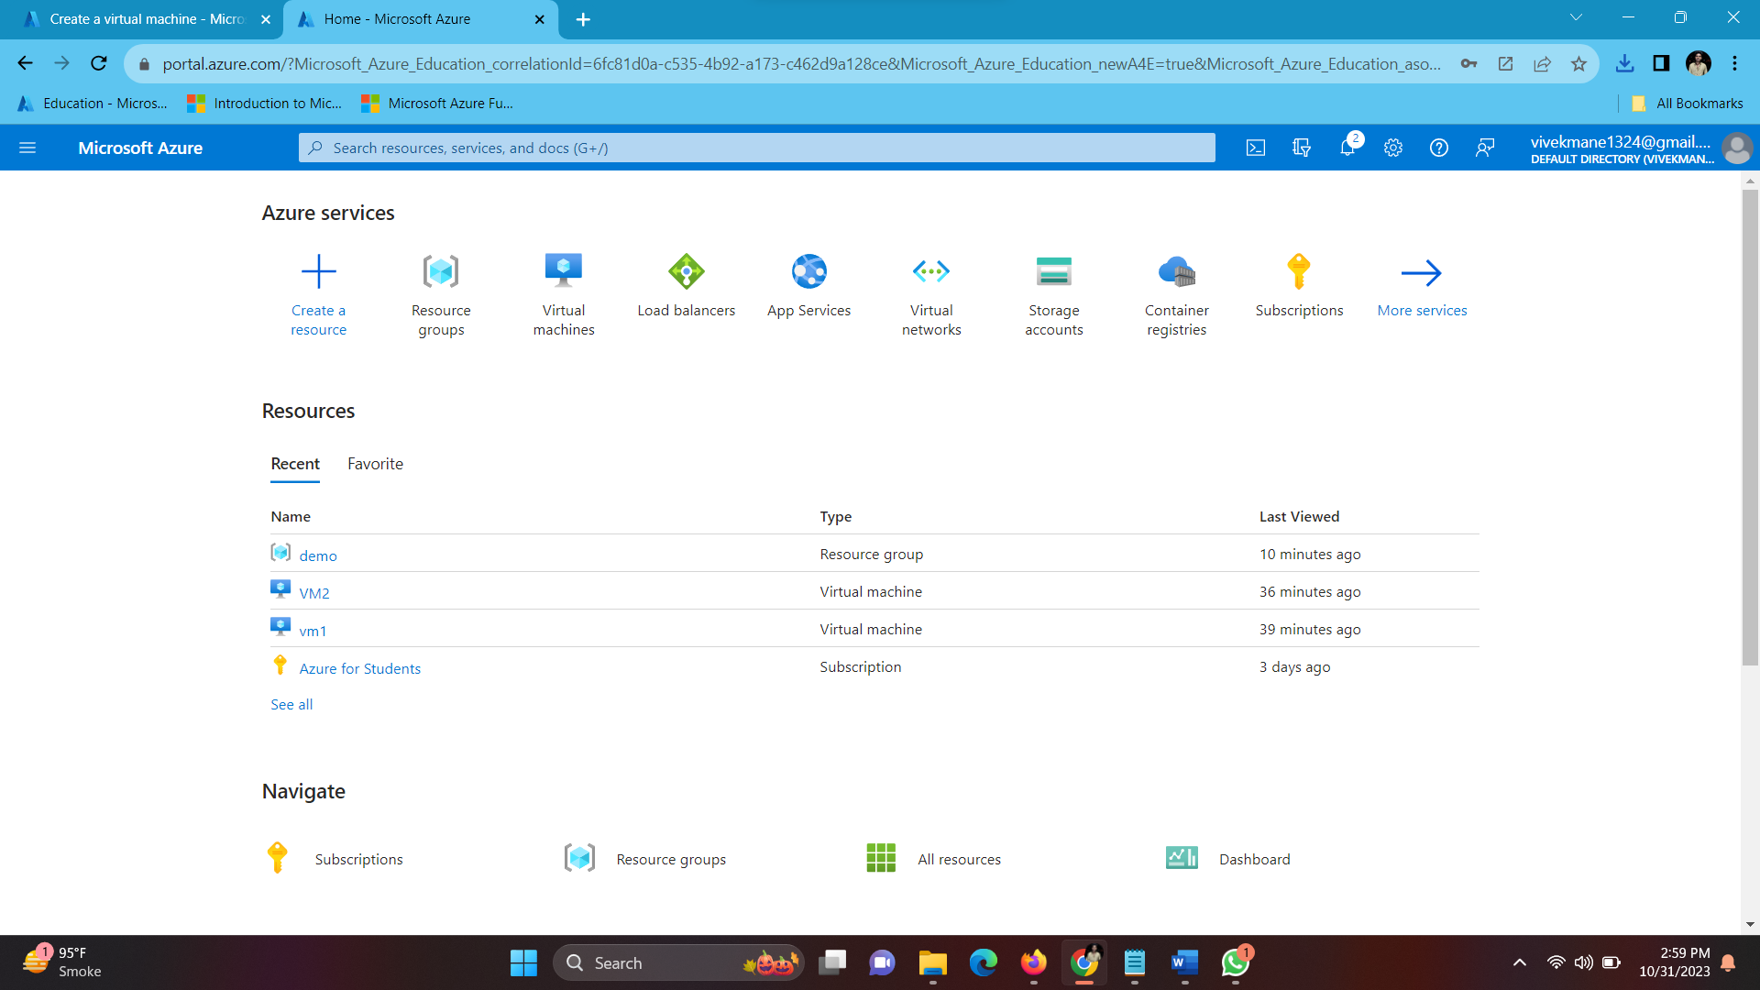

Click on Create a Resource > Virtual Machine.

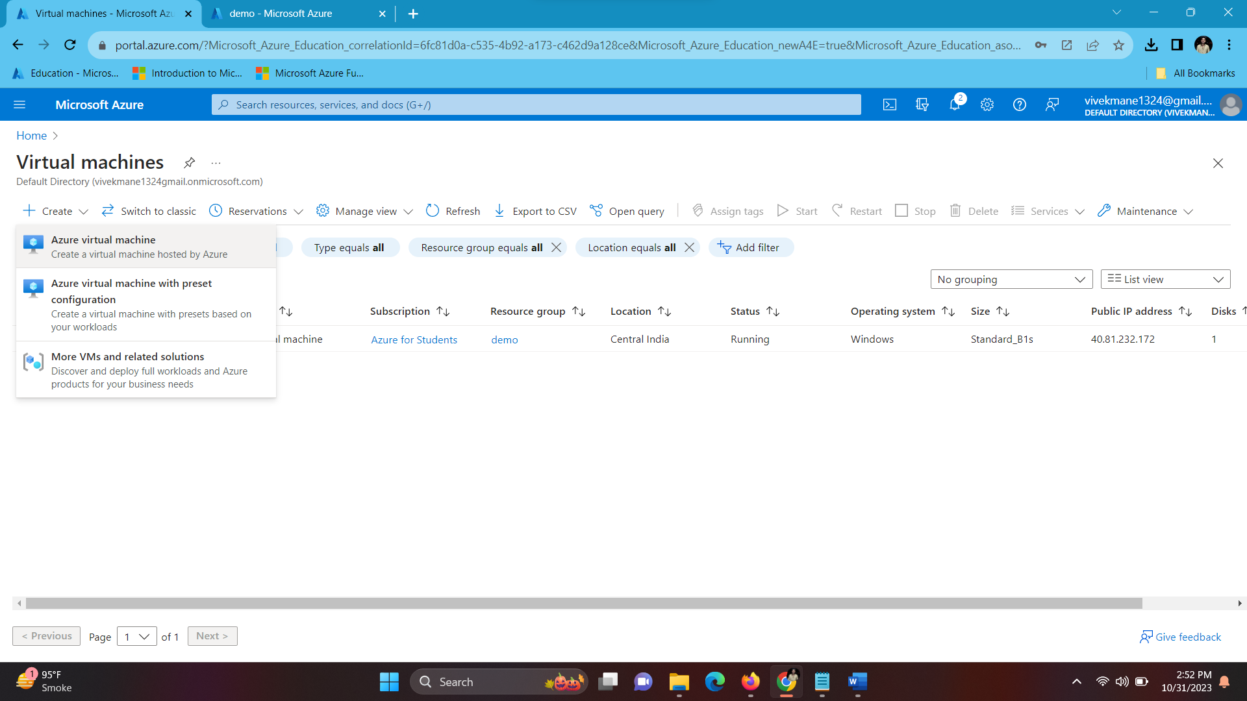

Fill the necessary details Then select the size of the VM and give it a username and password.

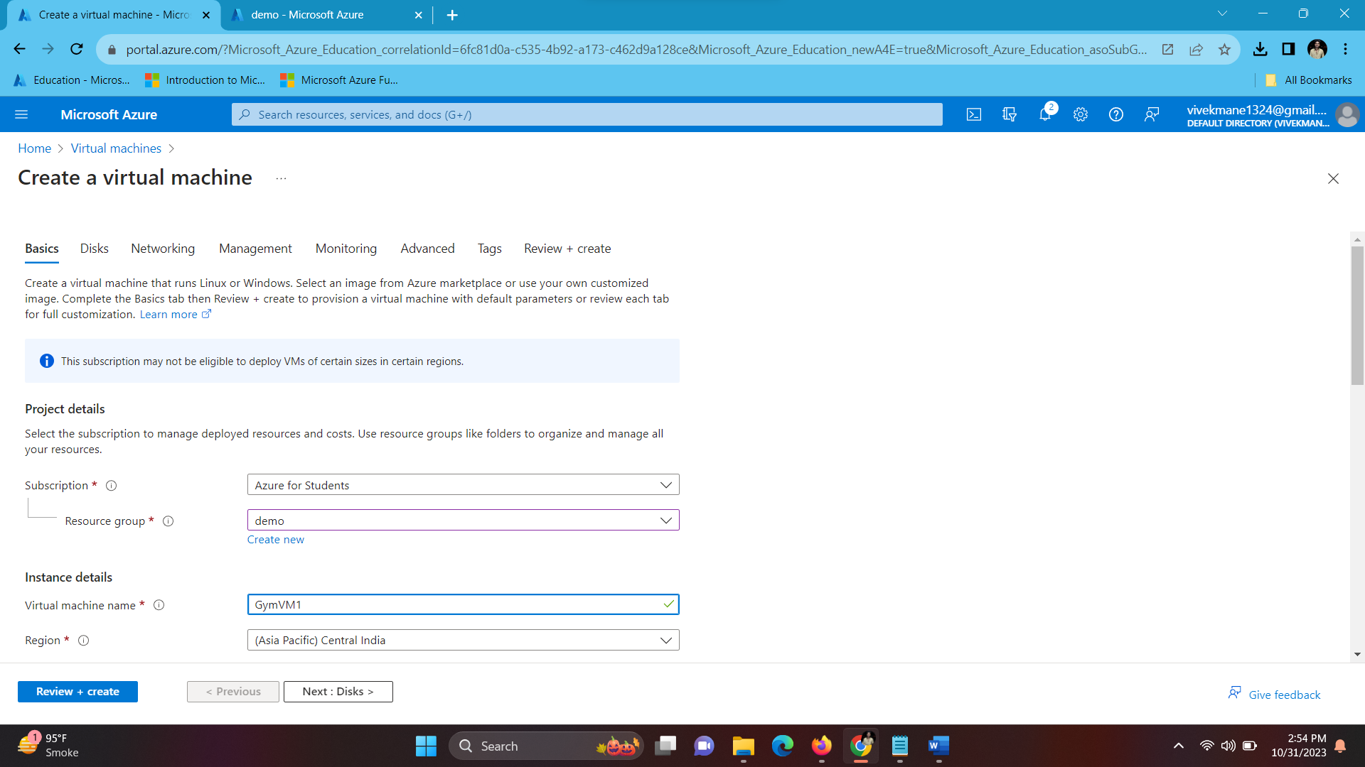

Select the inbound ports. HTTP (80), RDP (3389) then click on ‘Next: Disks’.

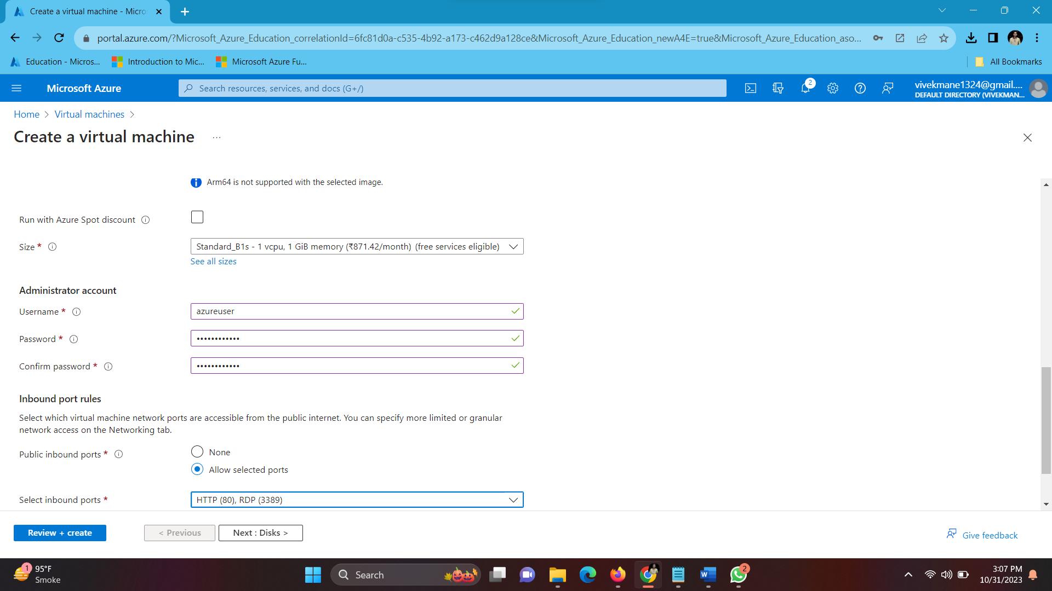

Select the ‘standard SSD’ as OS disk type.

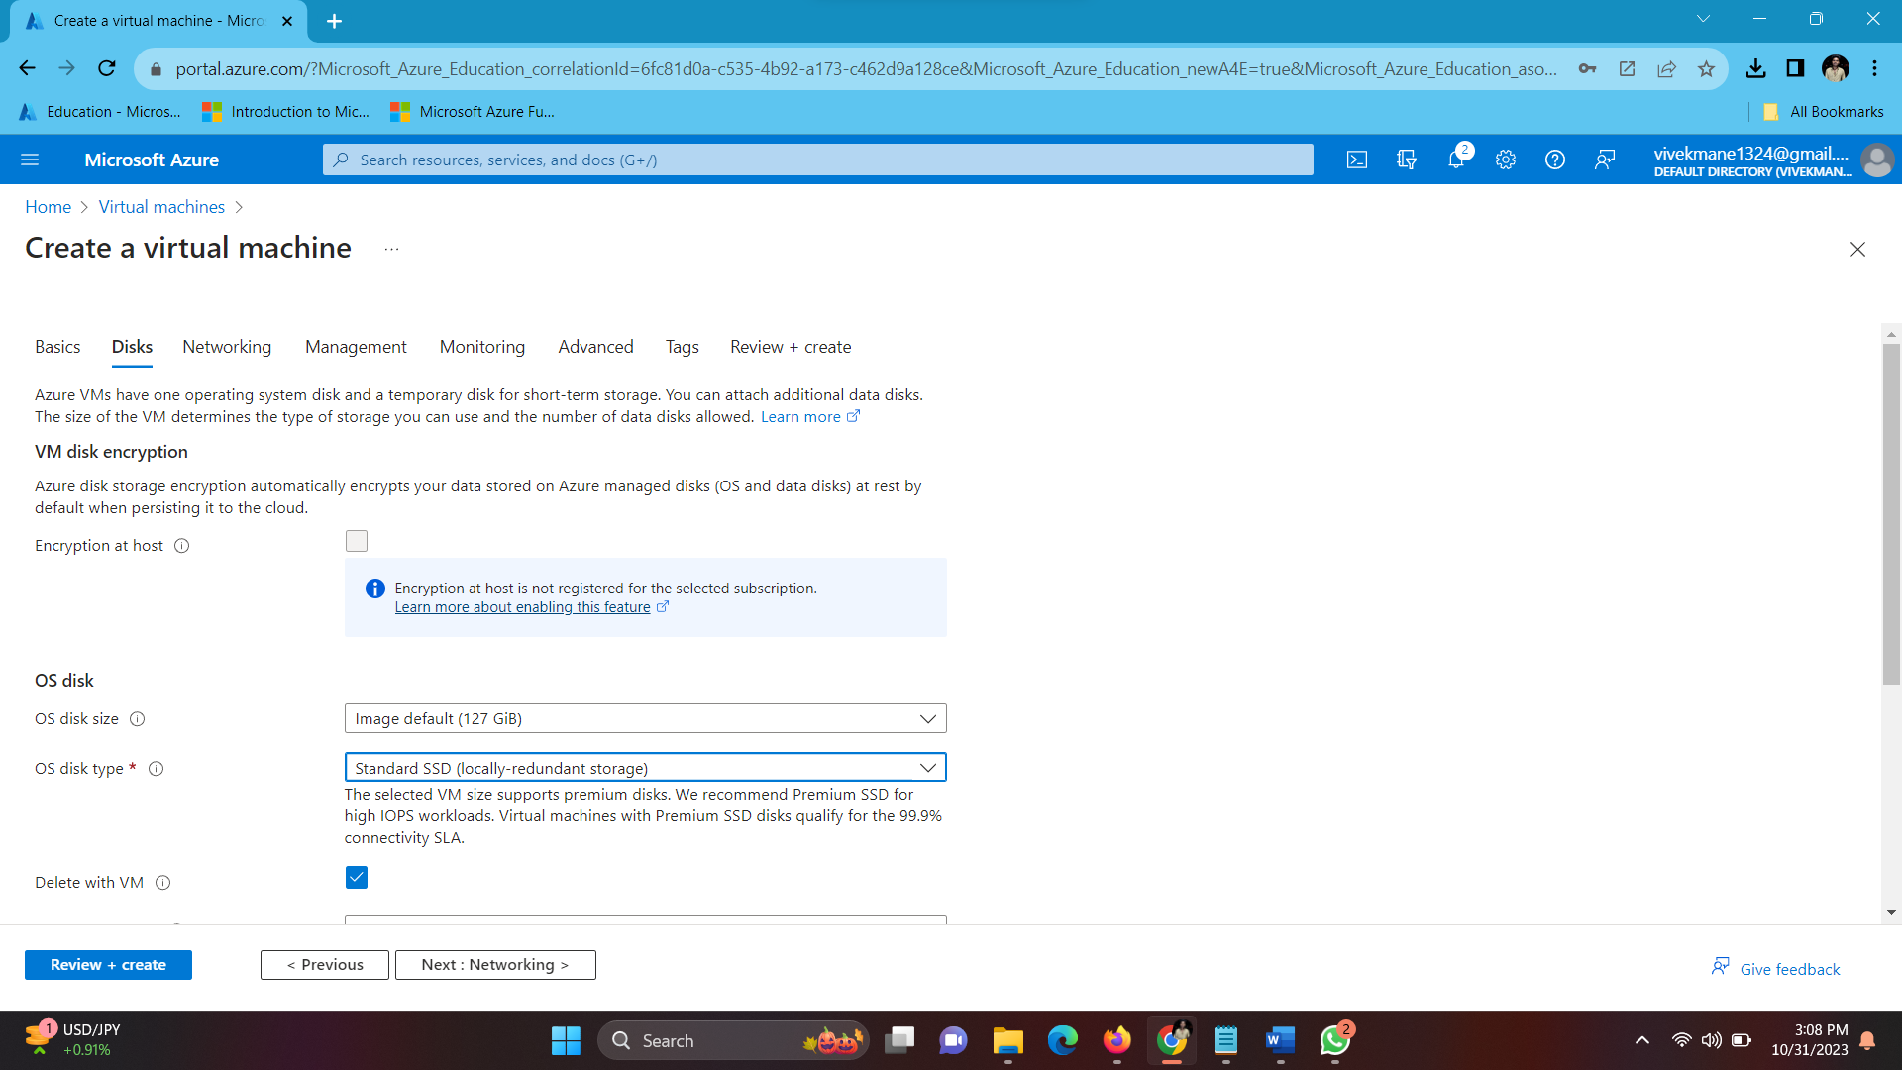

Click on review and create.

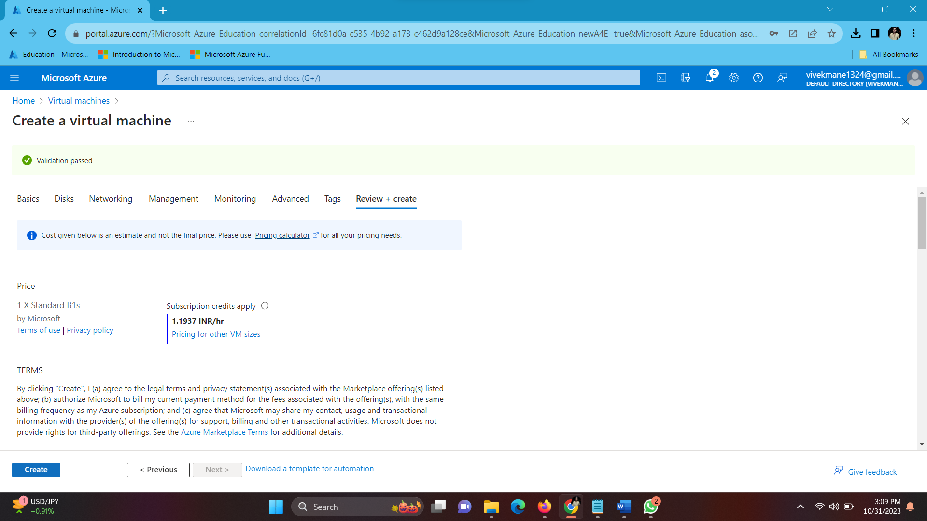

Wait for your deployment to get completed, then click on go to resource.

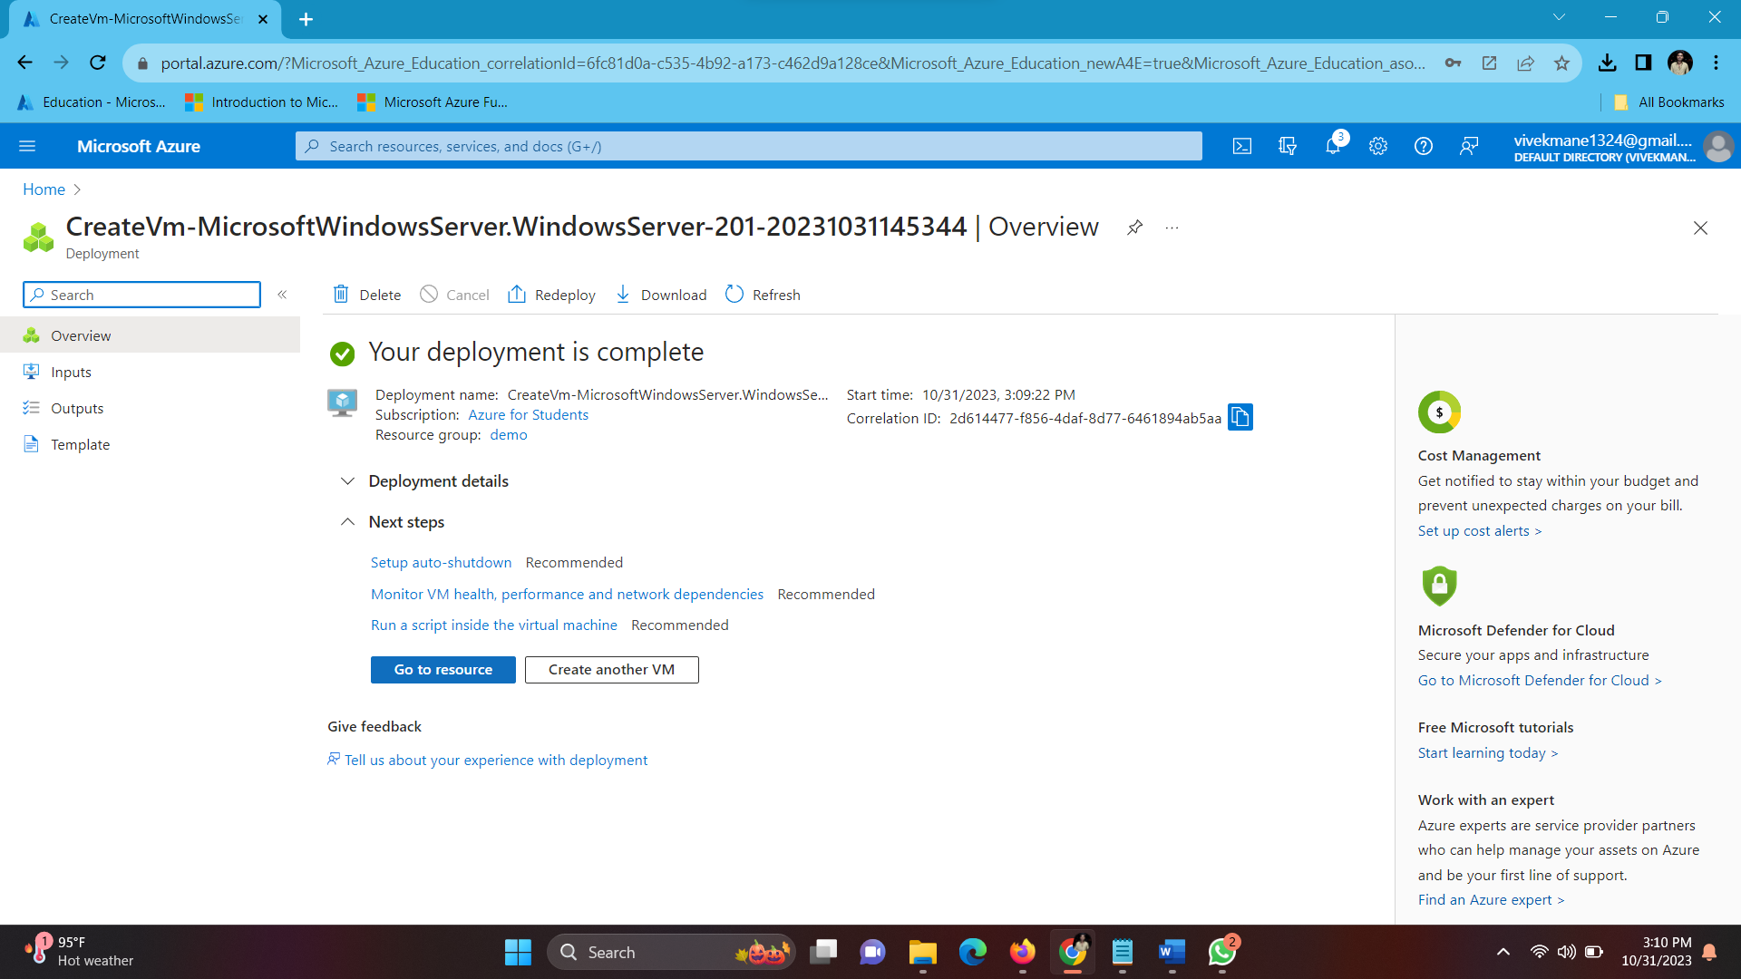

Click on the ‘Connect’ button.

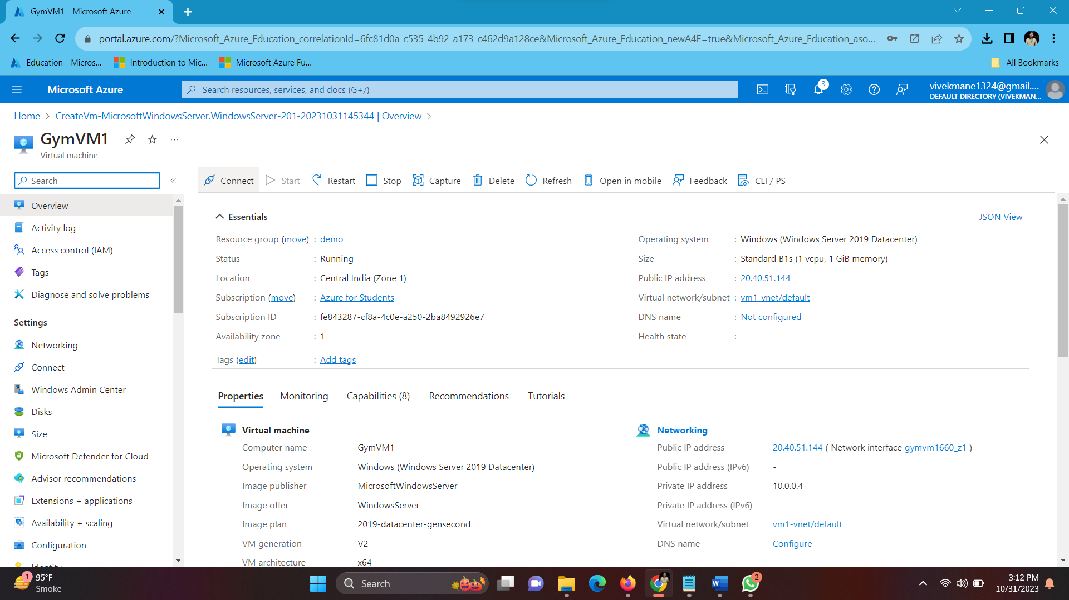

In the native RDP Box click on select, then wait for it to check the prerequisites, when done download the RDP file.

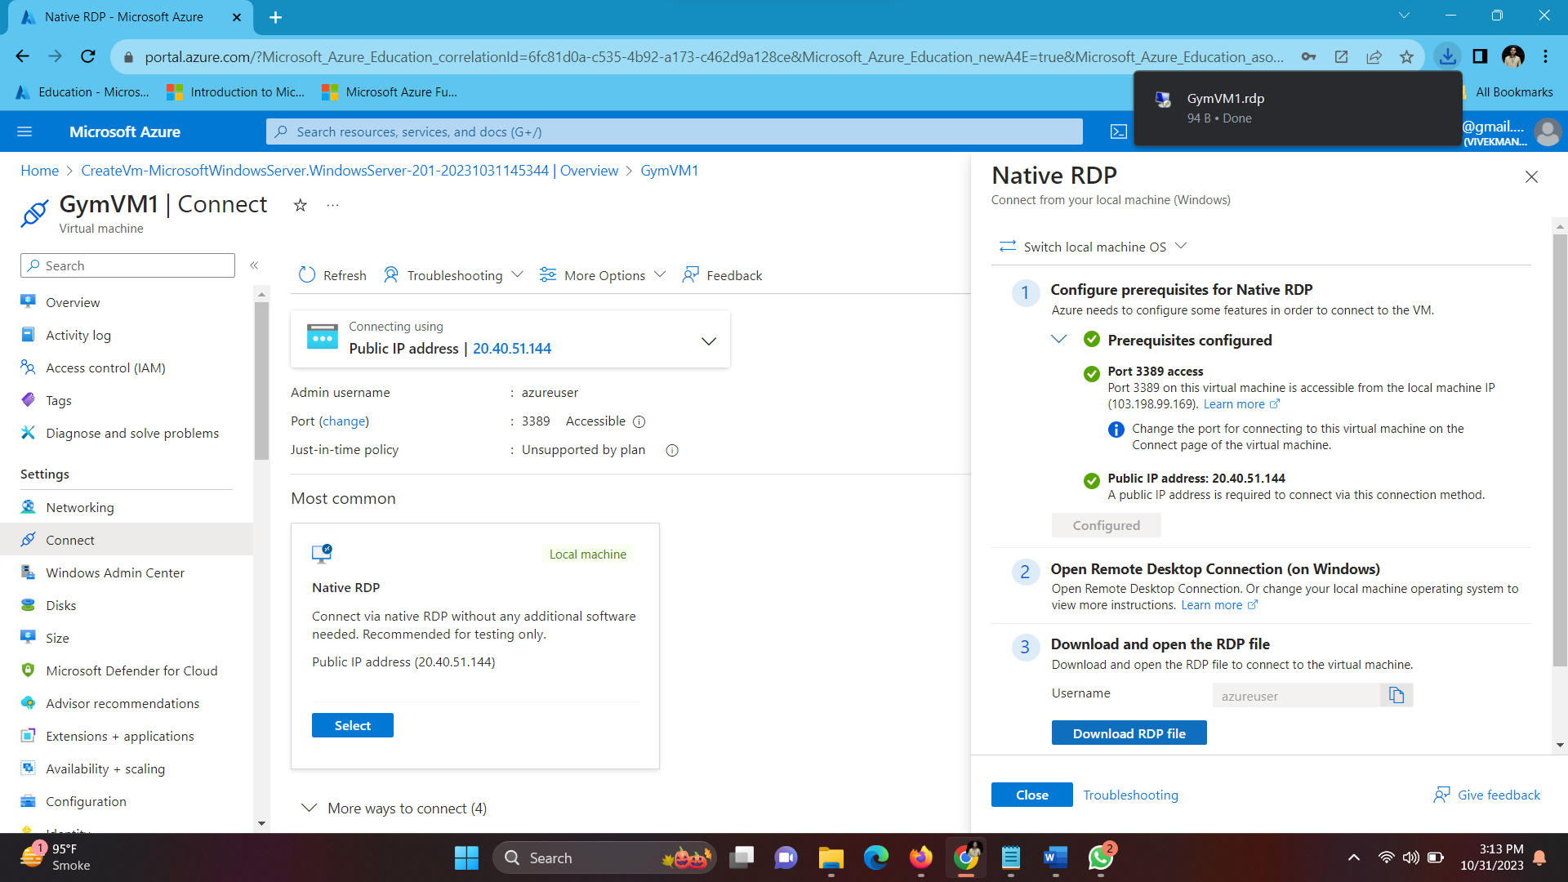

Now enter the Username and Password that you created and connect with remote desktop.

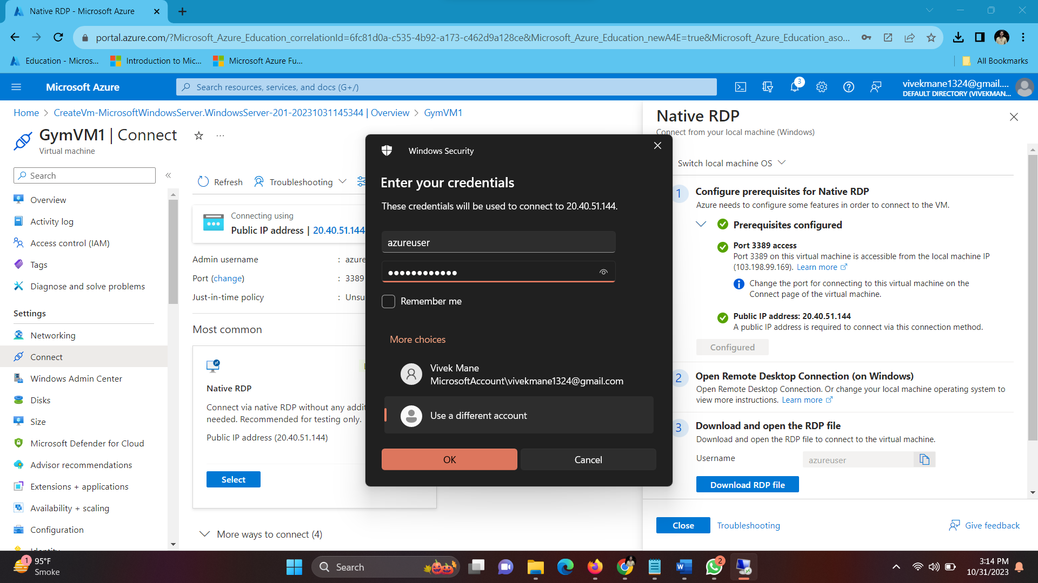

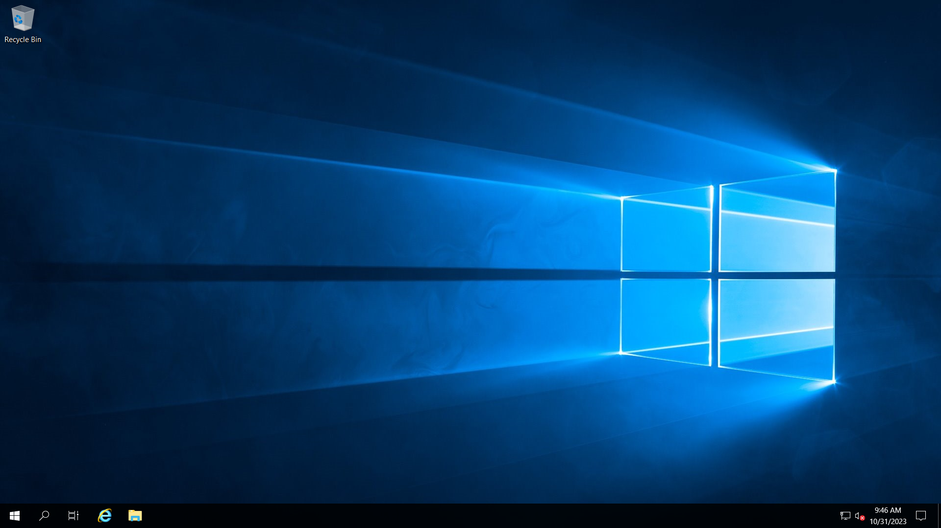

Open the server manager dashboard > open Add Roles and Features Wizard > click on Server Roles > Web Server (IIS) and press install.

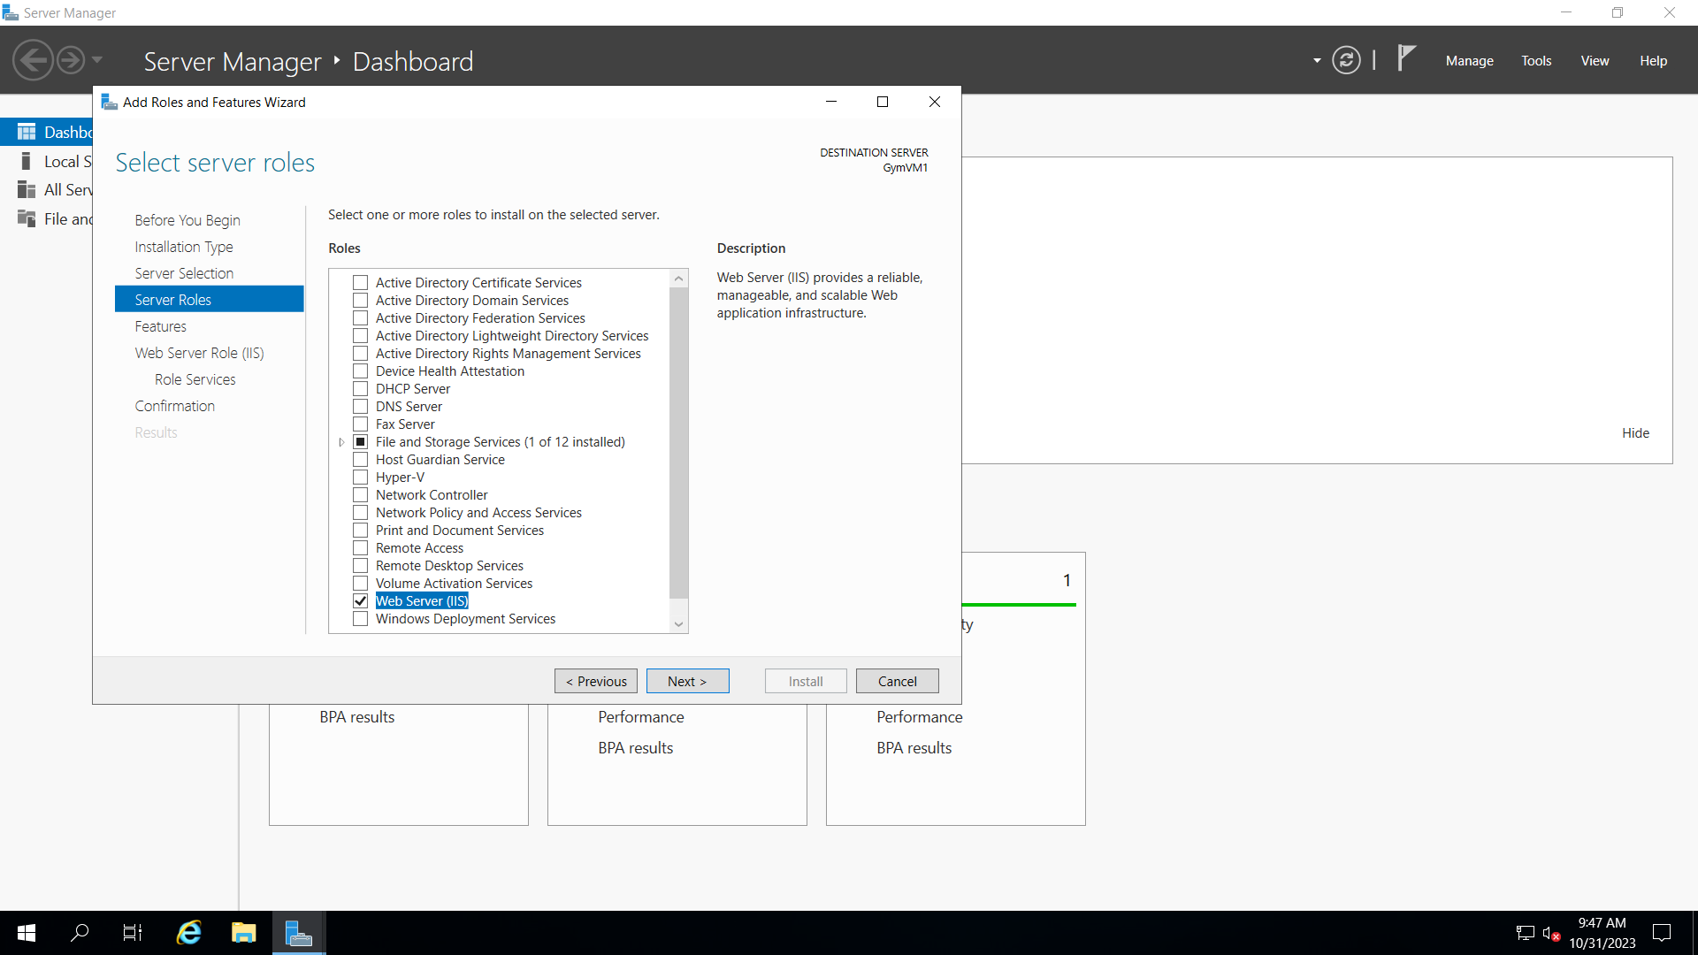

Wait for the installation to get complete

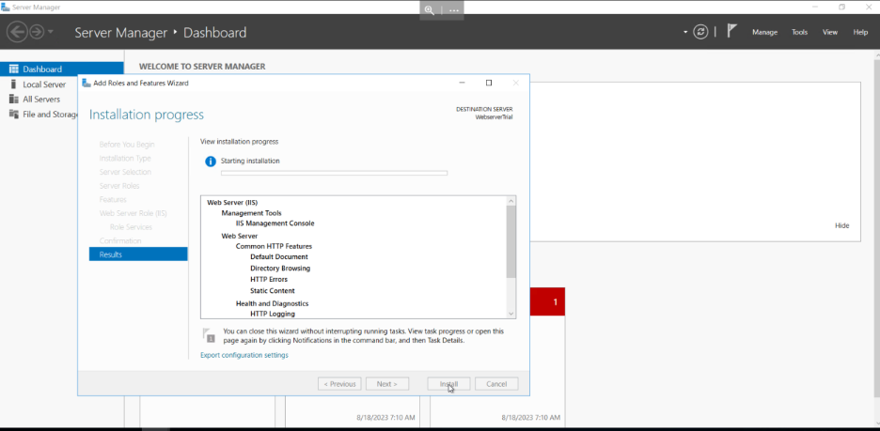

Then open This PC > C: Drive > inetpub > wwwroot > .html file.

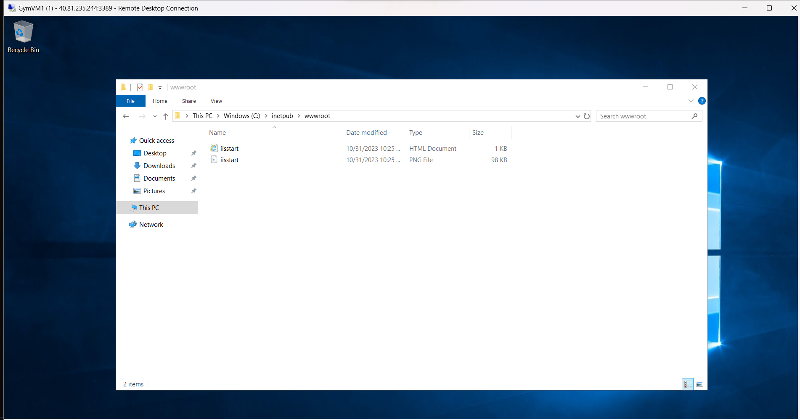

Now the Delete Existing files and paste project file from our system to wwwroot folder

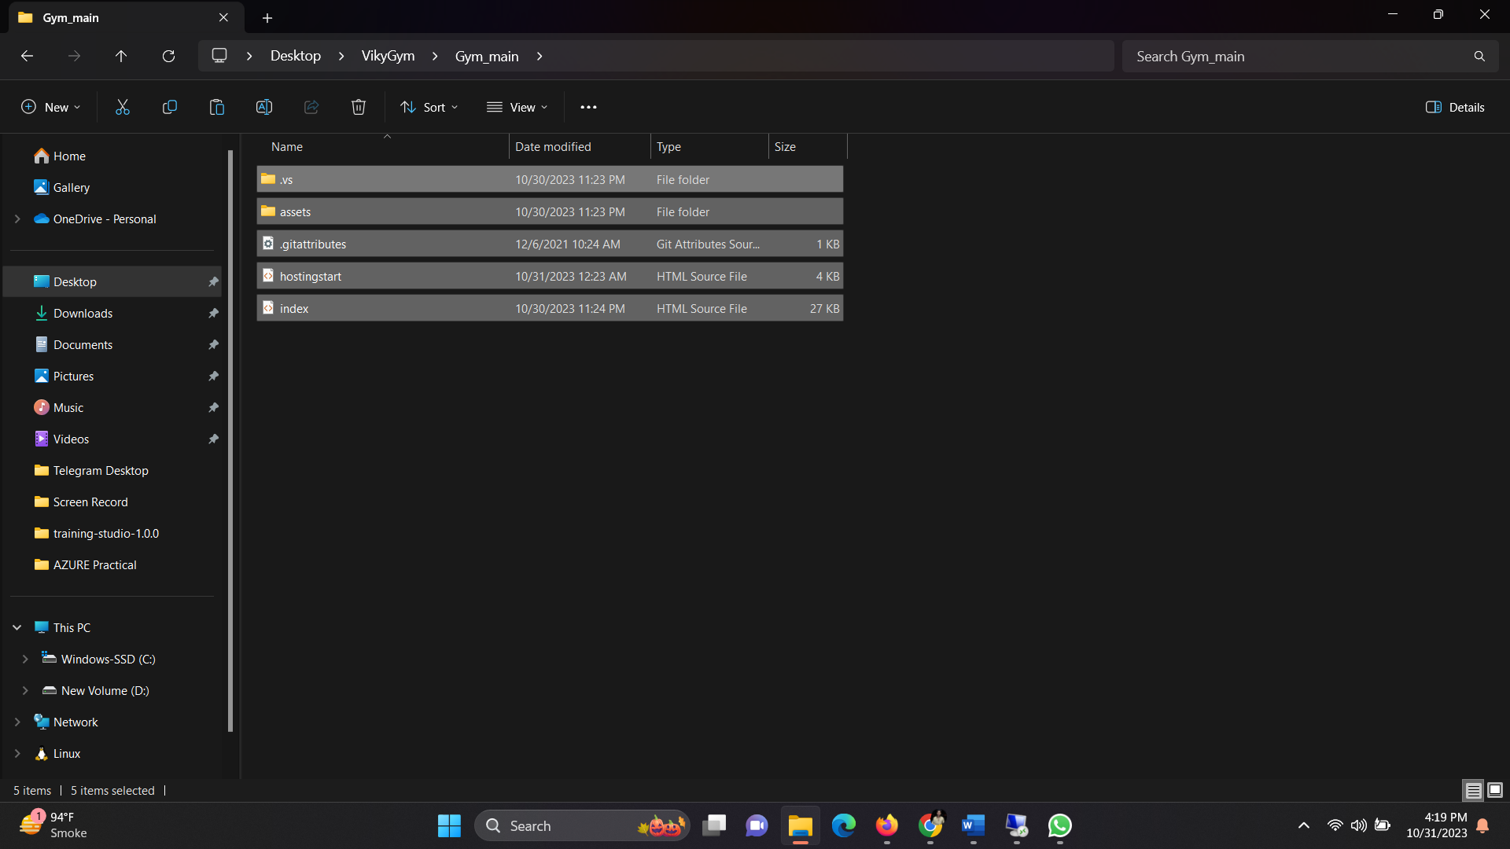

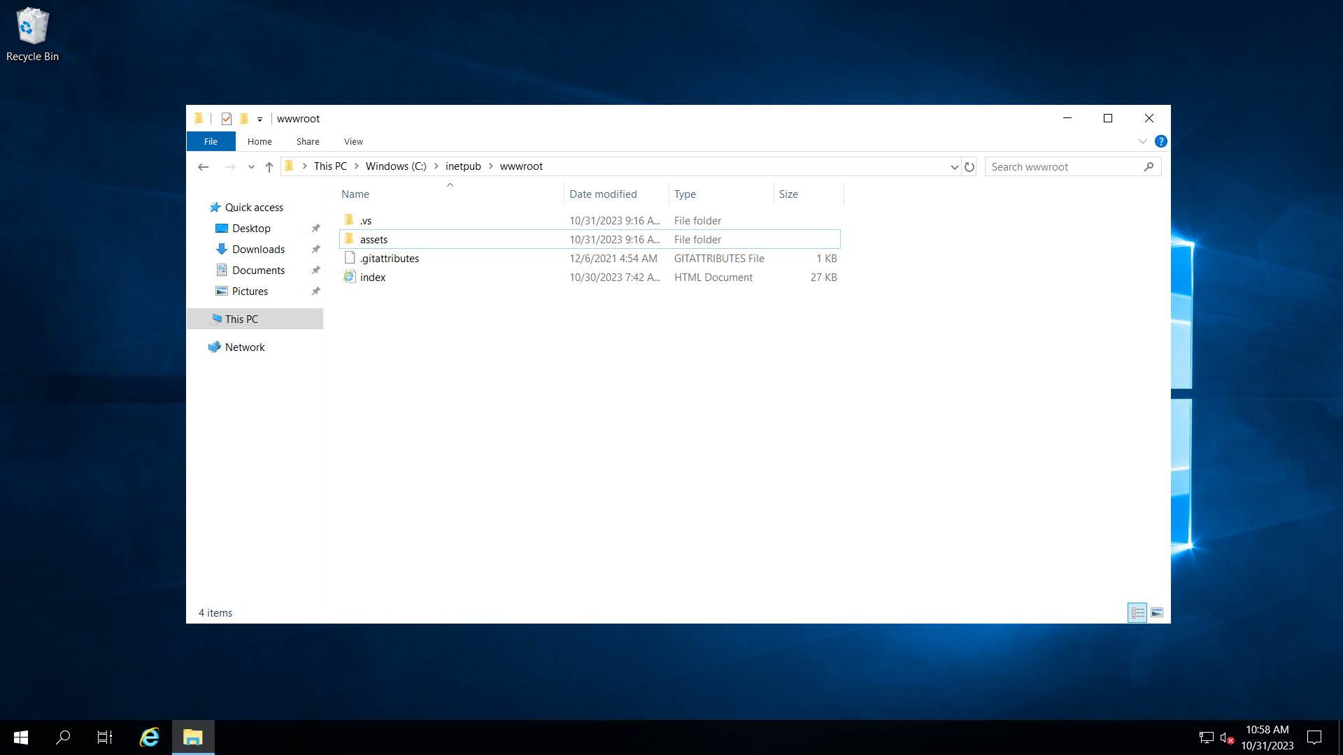

Copy the VM’s public IP and paste and run it through your browser.

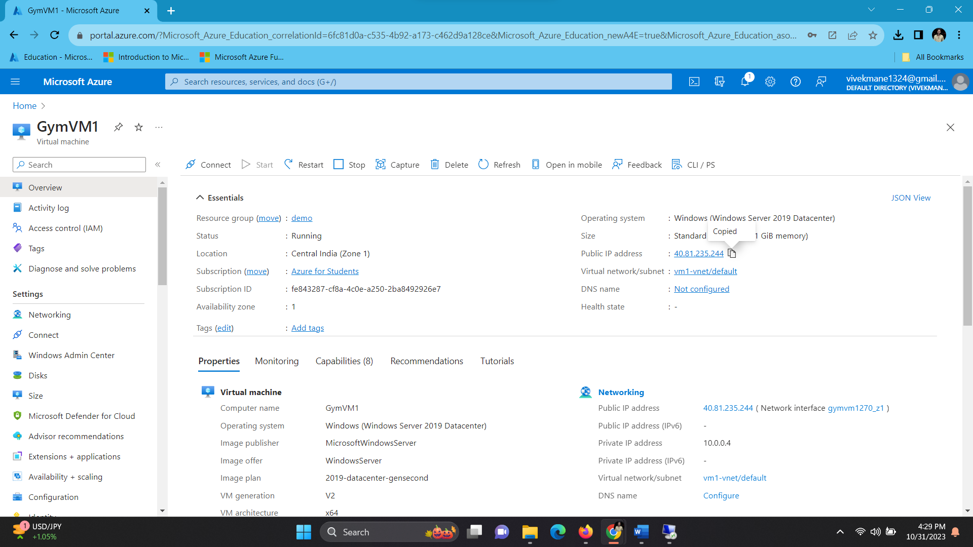

Our Webpage is Successfully uploaded on VM

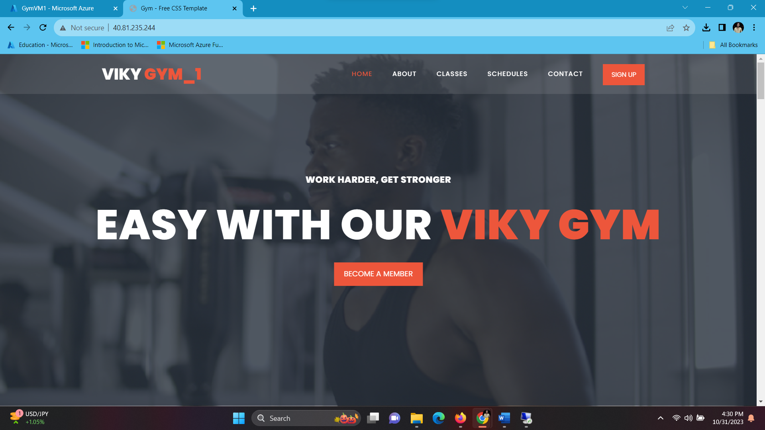

Create One more VM Same as previous

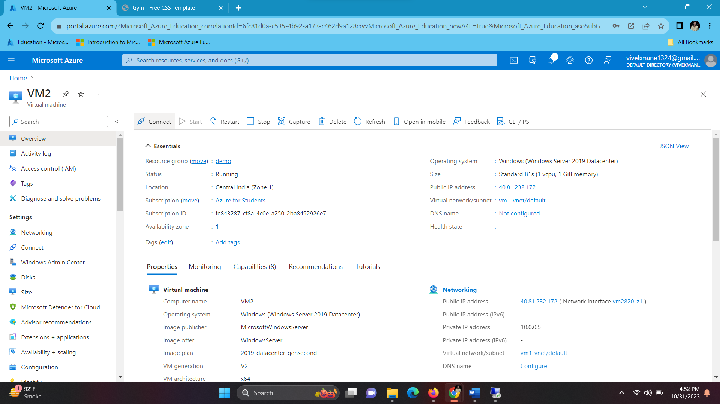

Install Web Service (IIS)

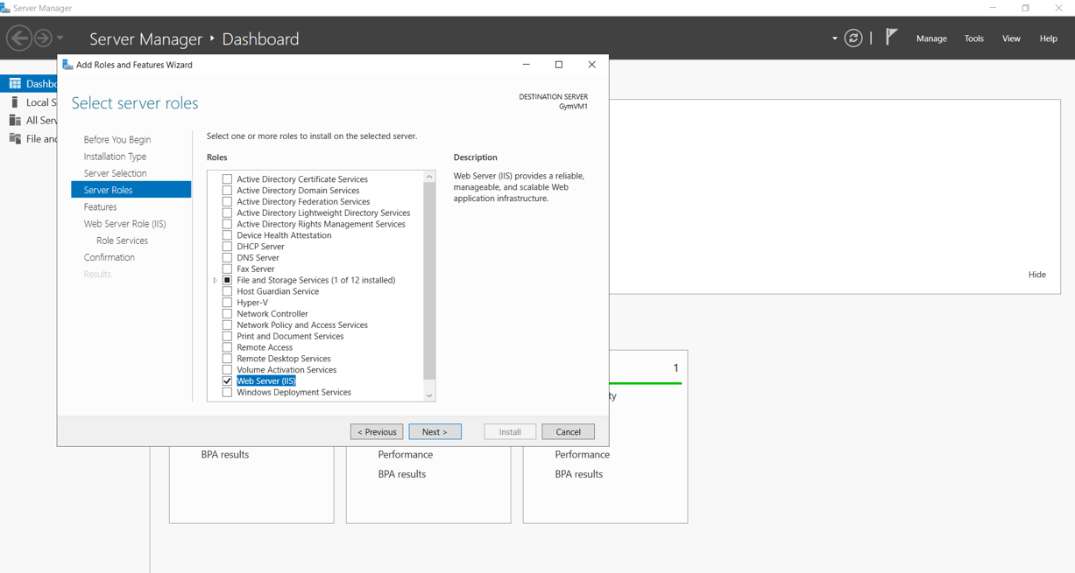

Then open This PC > C: Drive > inetpub > wwwroot > .html file.

Now the Delete Existing files and paste project file from our system to wwwroot folder

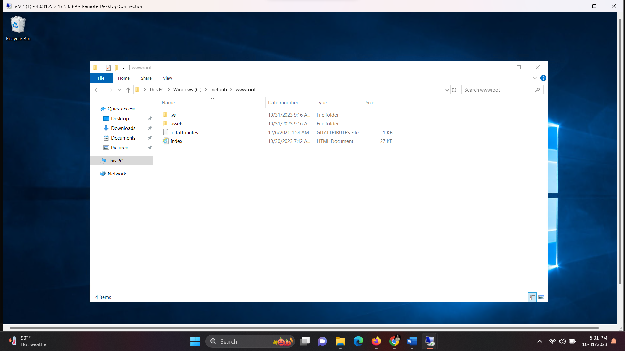

Copy the VM 2’s public IP and paste and run it through your browser.

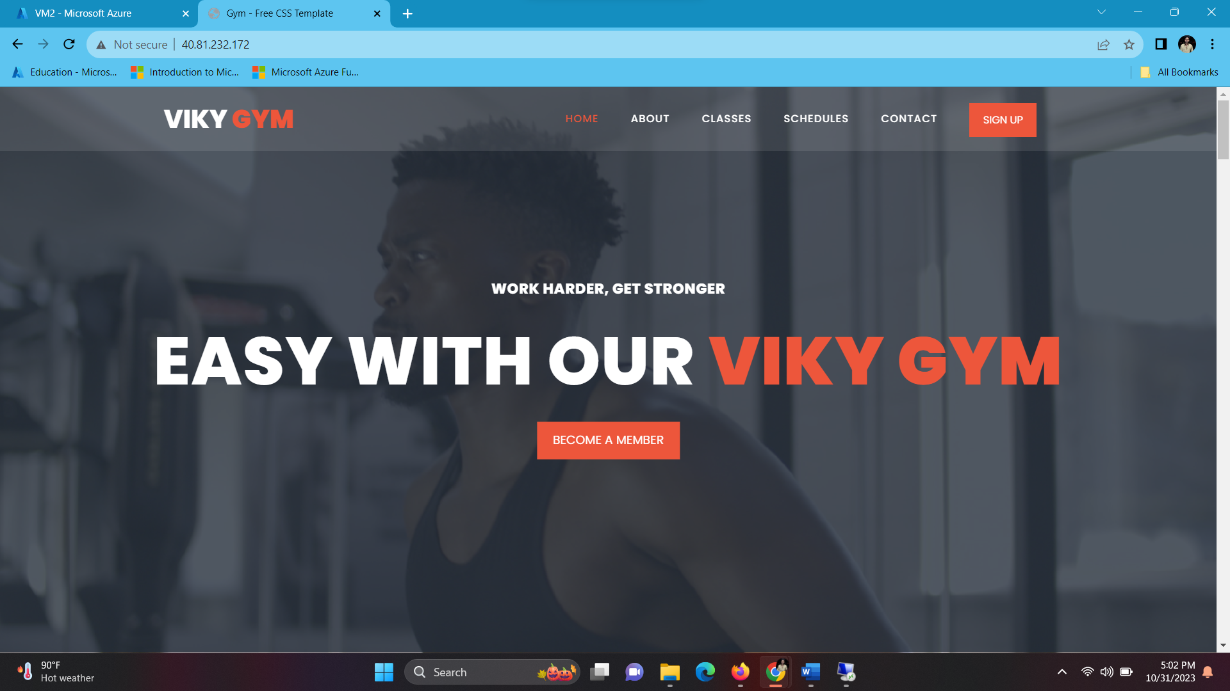

Now deploy an application gateway (layer 7 Load Balancer) for single site. :

Create Application gateway

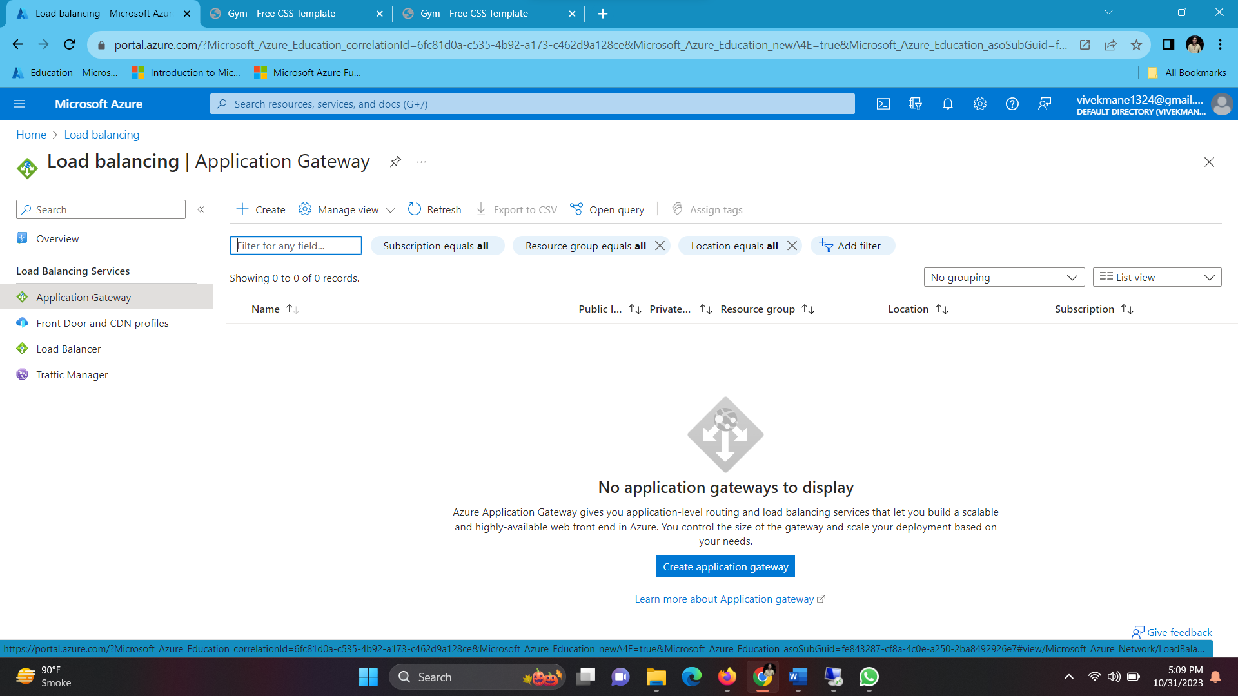

. Basic: give name > region > Tier (WAF v2) >Autoscaling (Disable) > instance count (1) > Http2 (disable) > WAF policy (create new: give name > enable bot protection).

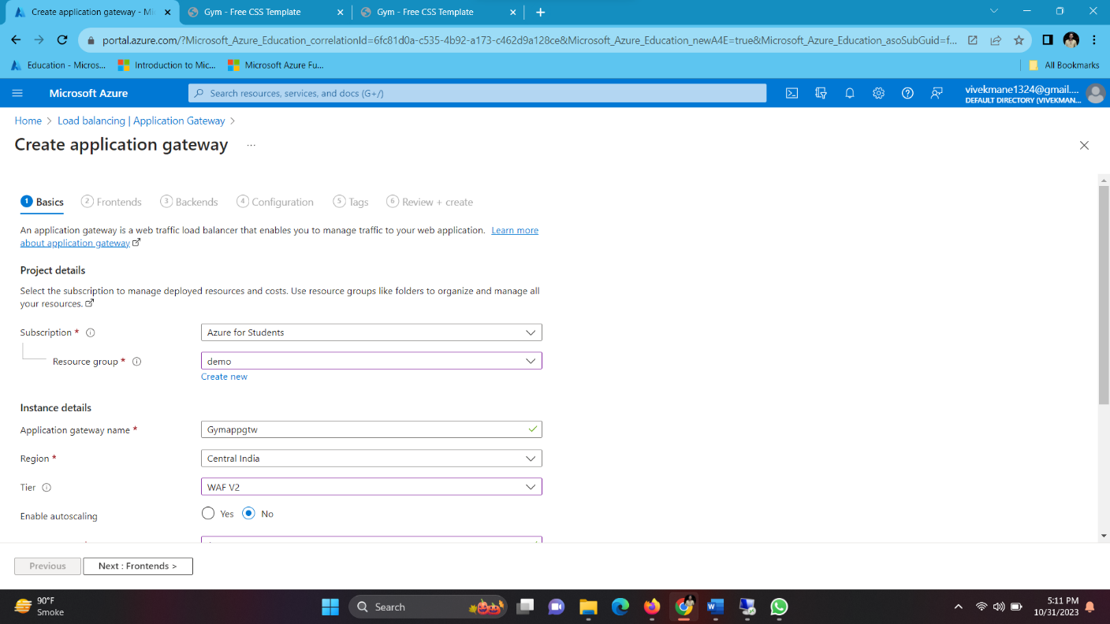

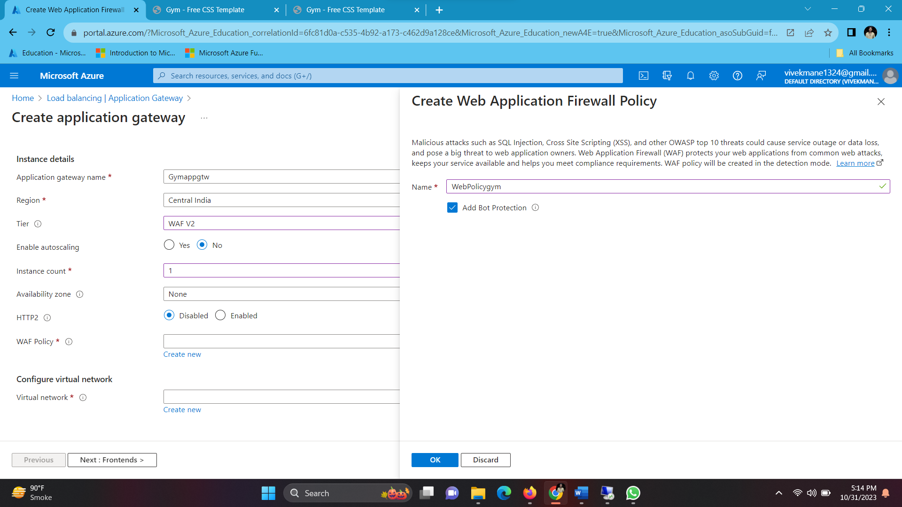

Frontend: Give name > address type (public) > ip address (create new)

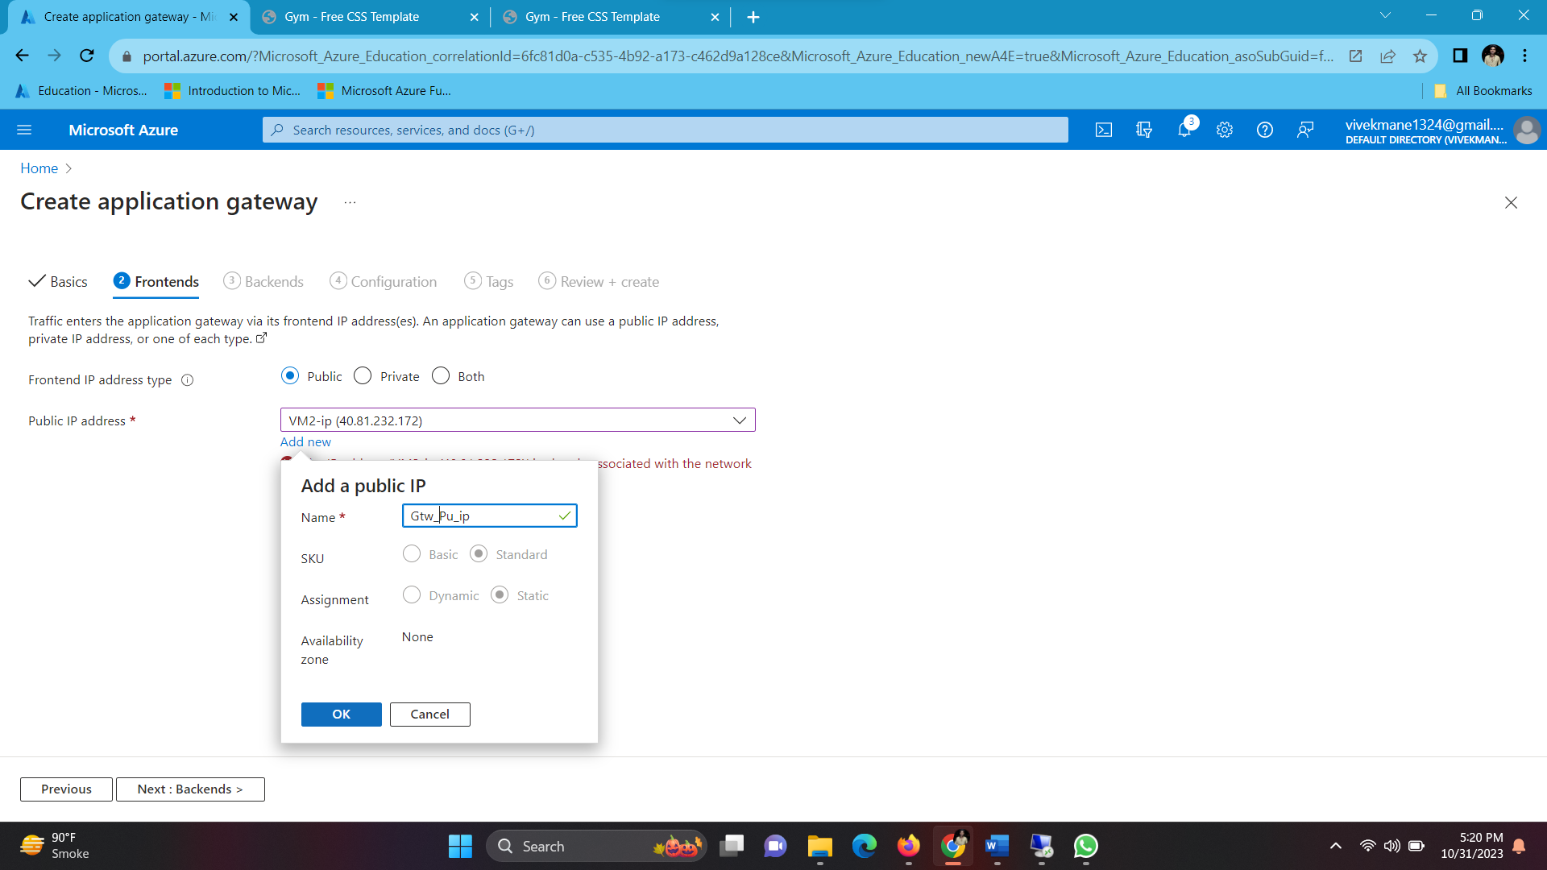

Backend: Backend pool (give name) > Target Type (add: VM1 and VM2) >add.

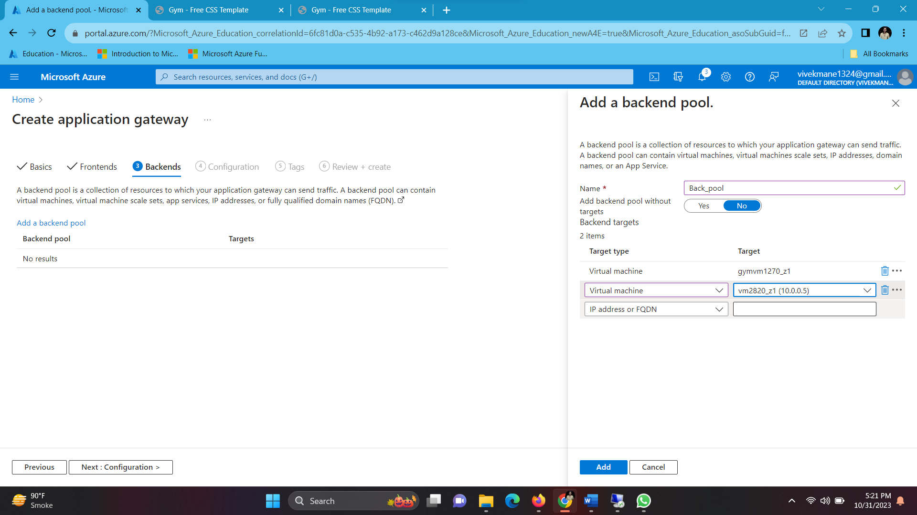

Configuration: Routing table > give name > priority (500)> Listener> give name >

frontend_IP (public) > protocol (Http) >port (80) >Listener type (basic).

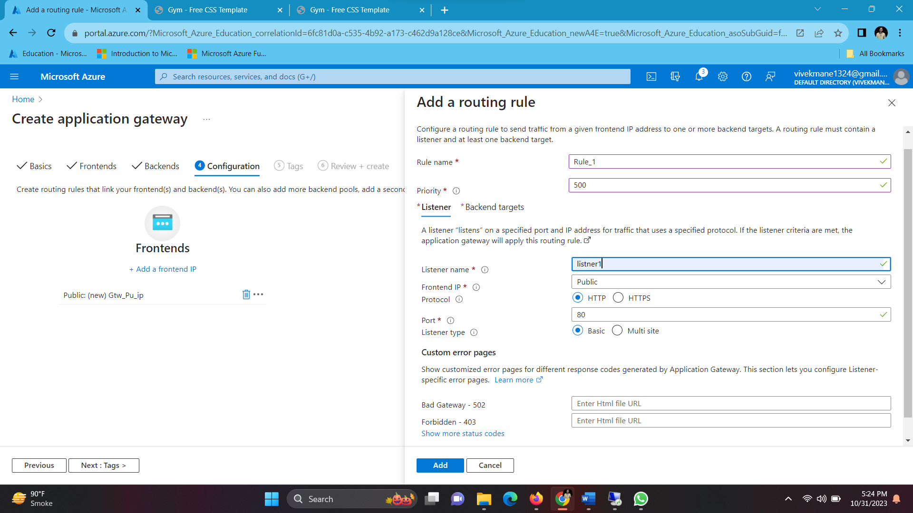

Backend target : target type (Backend pool) > backend target (backend_pool_ip) >

backend settings: give name > http > port (80) > cookie based affinity (disable) >connection

draining (disable) > add > review + create

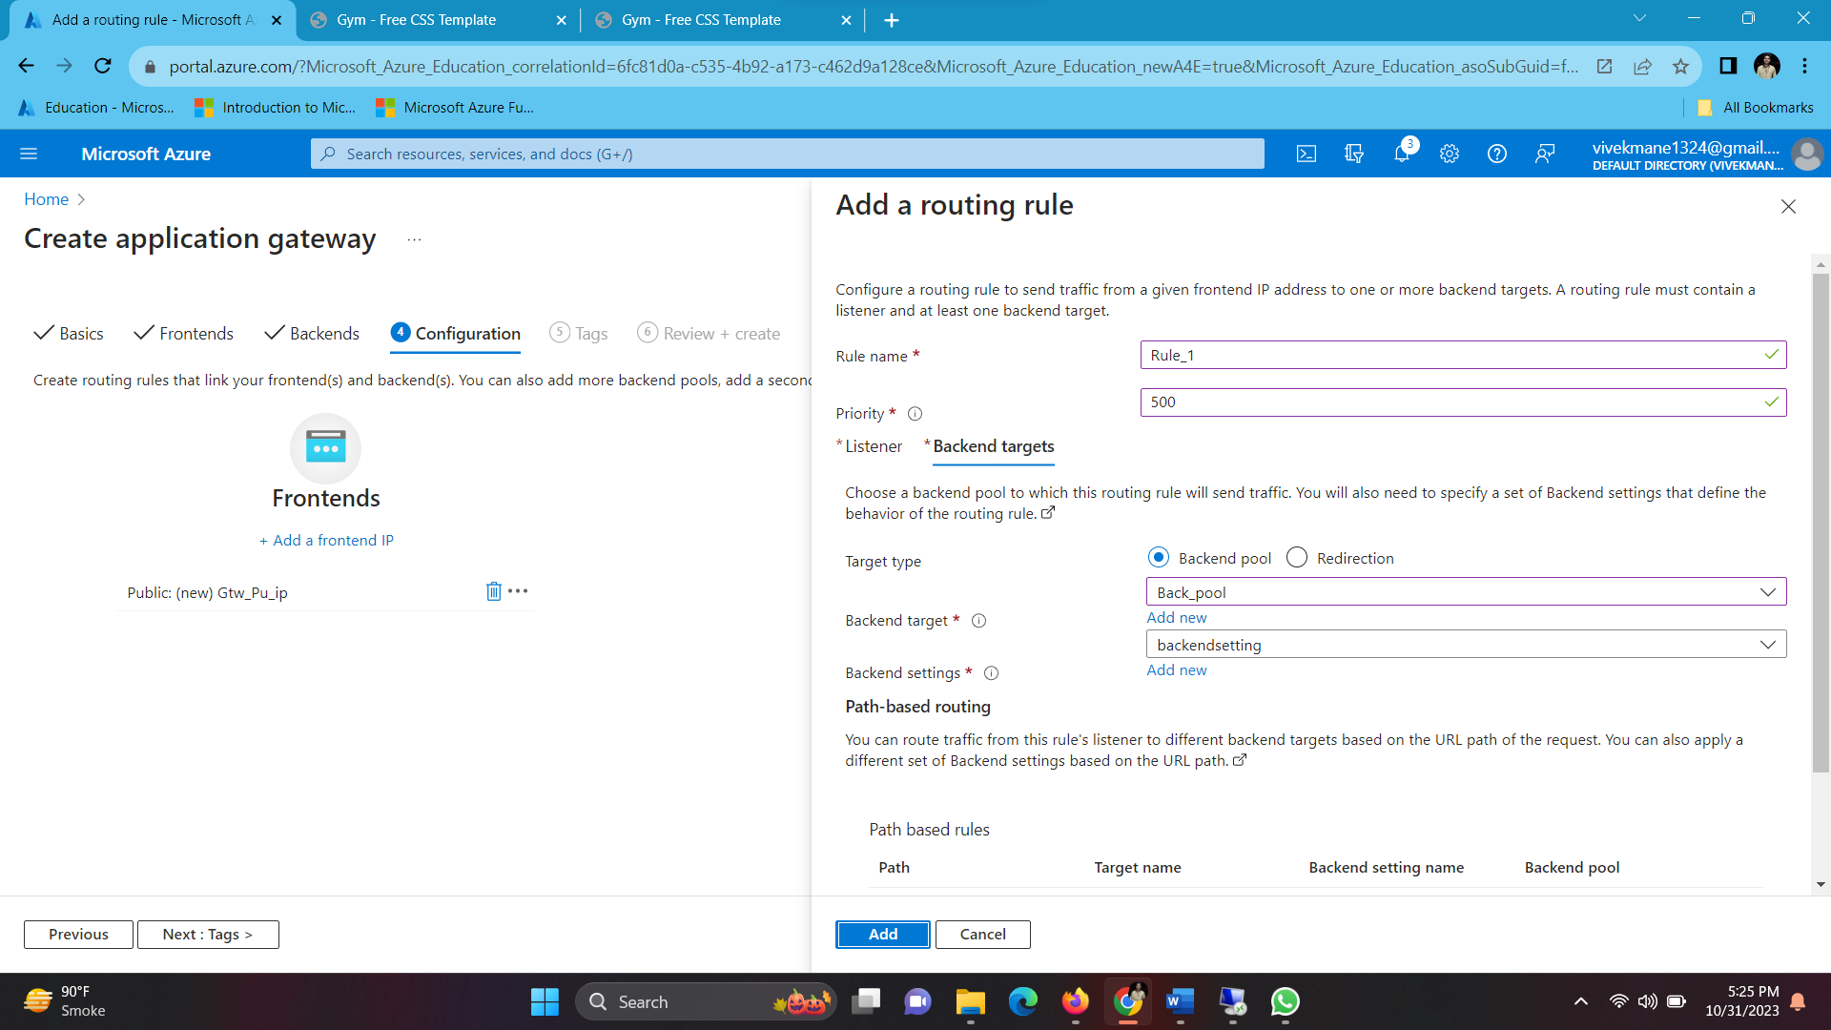

Wait for Deployment

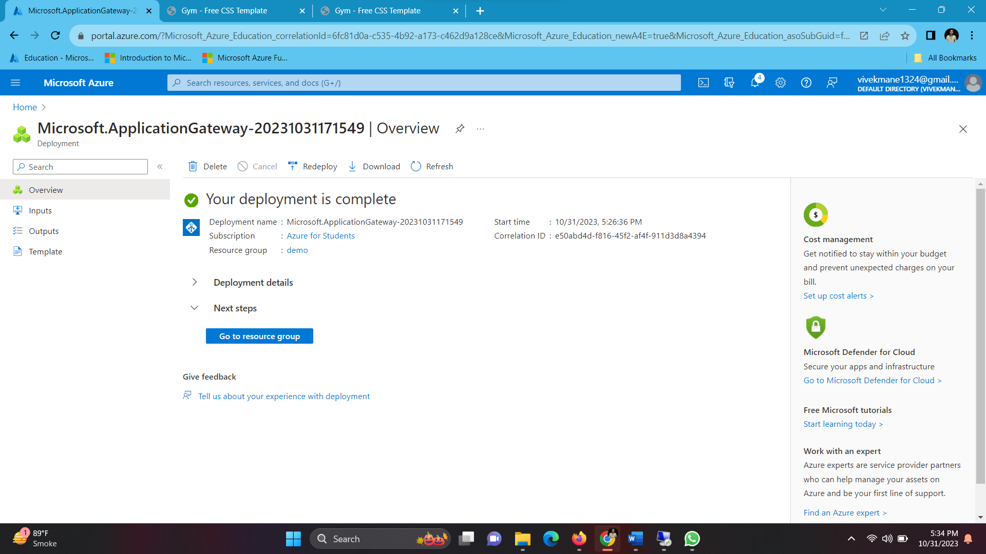

After deployment copy the Application gateway’s public ip and paste it in browser to see the load balancer work

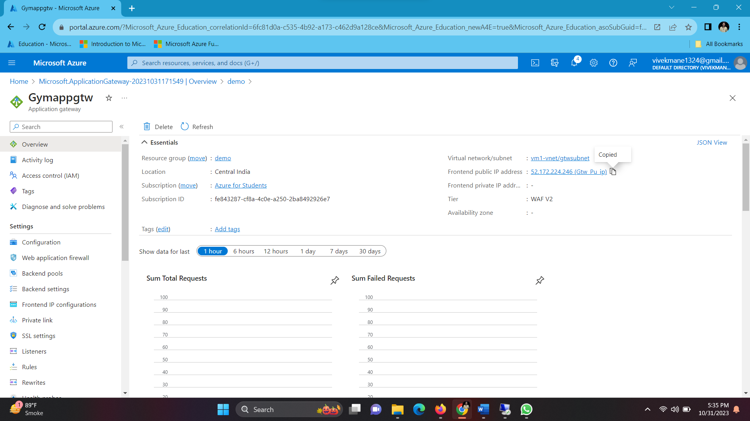

Here we can see our website is loaded successfully

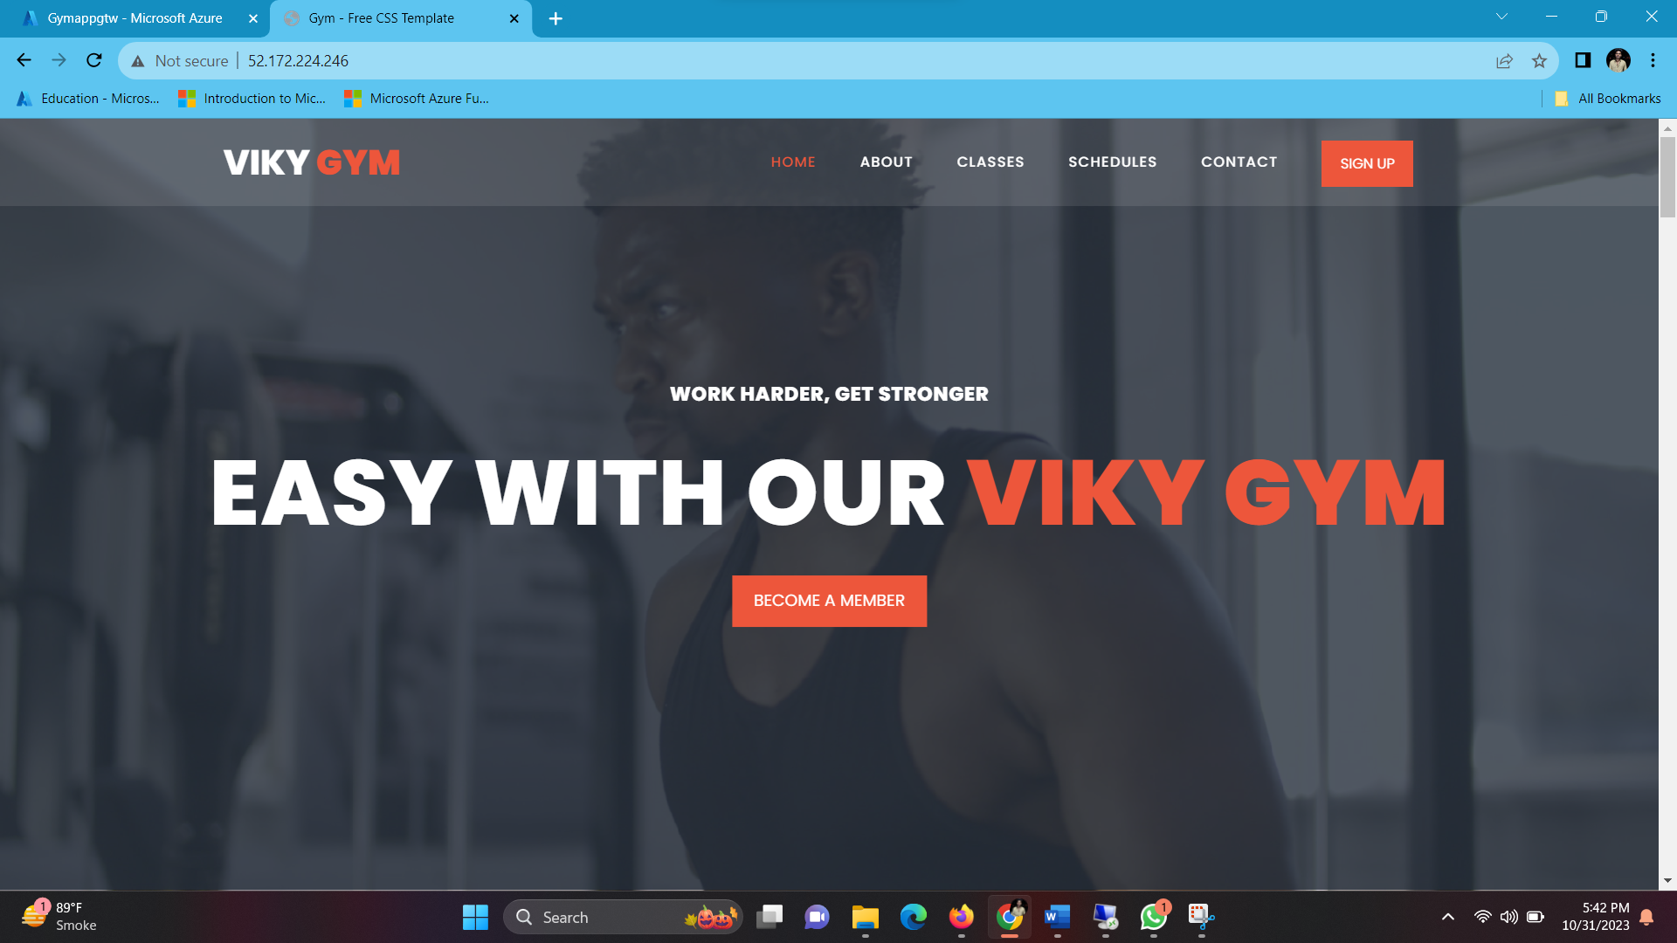

In order to check Application gateway (Load balancer ) working properly we make some changes in both Website Title name

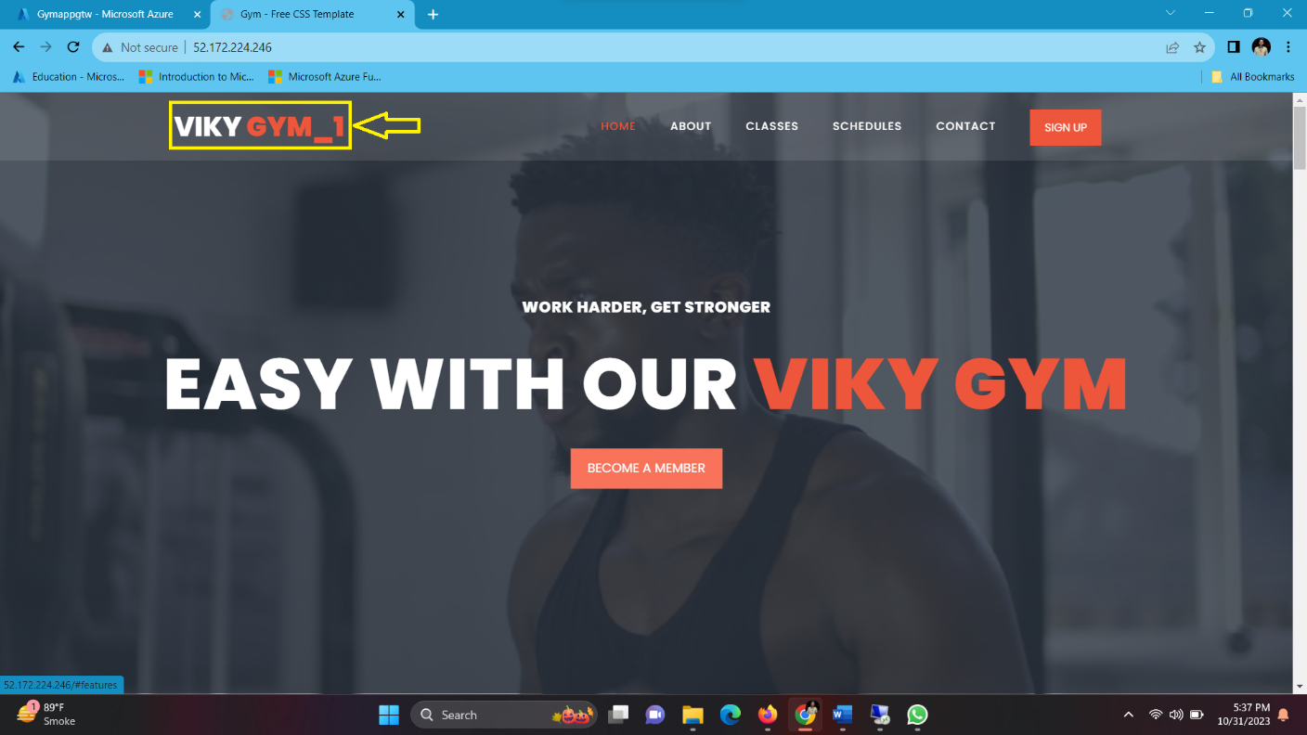

After Refreshing Tab Different Webpage loads .

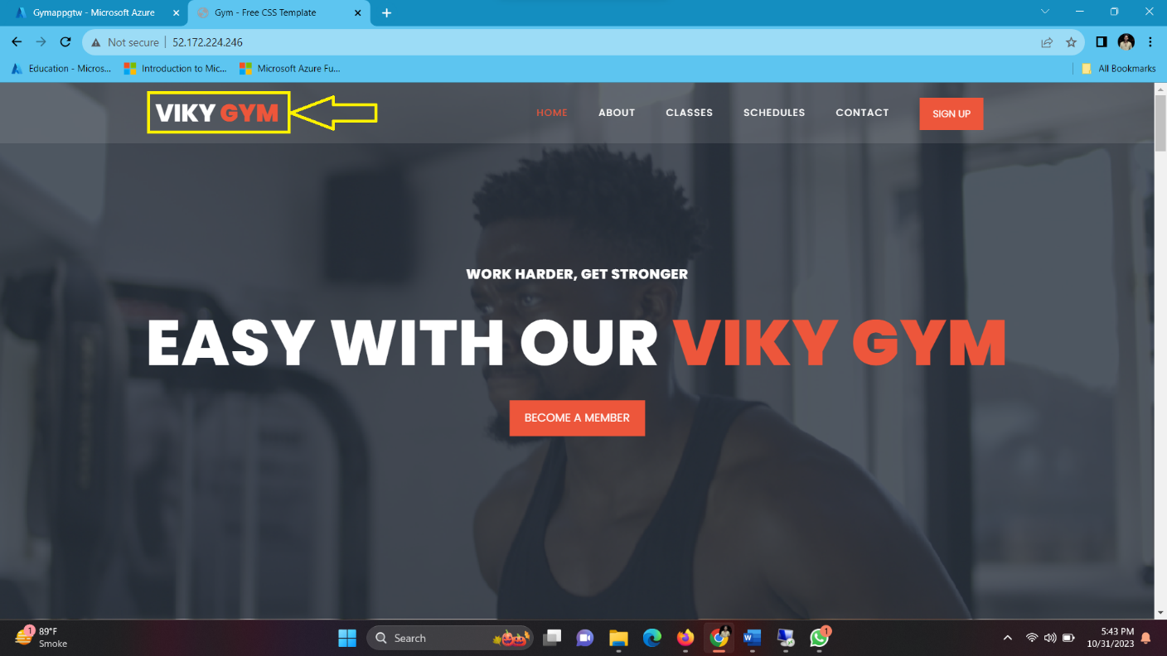

Here we can load balancer is working perfectly Fine.

Let’s Configure Default Azure DNS

Go to Resource group > Click on Gateway Public IP

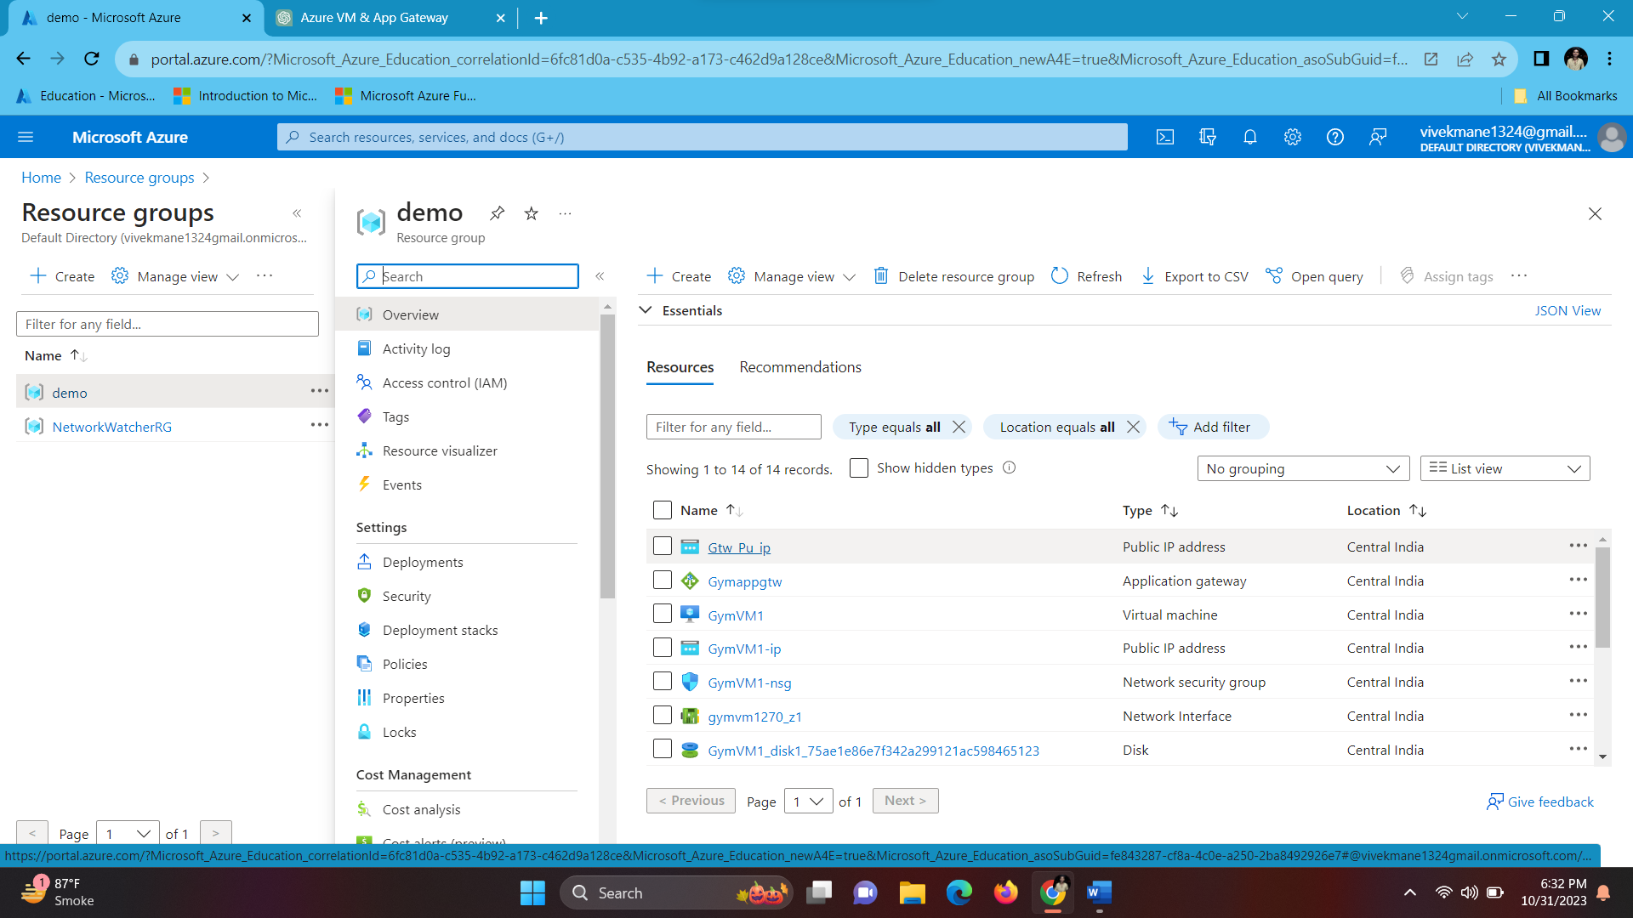

Configuration > Give Name > save.

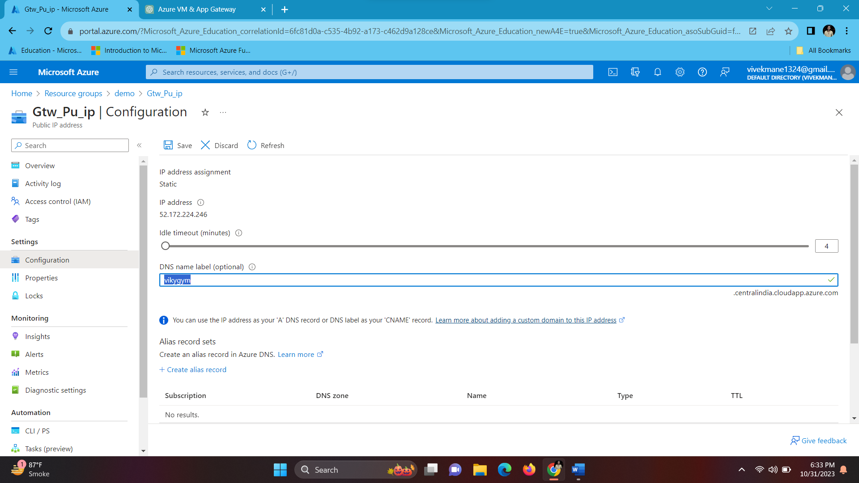

Copy DNS name & paste in new tab

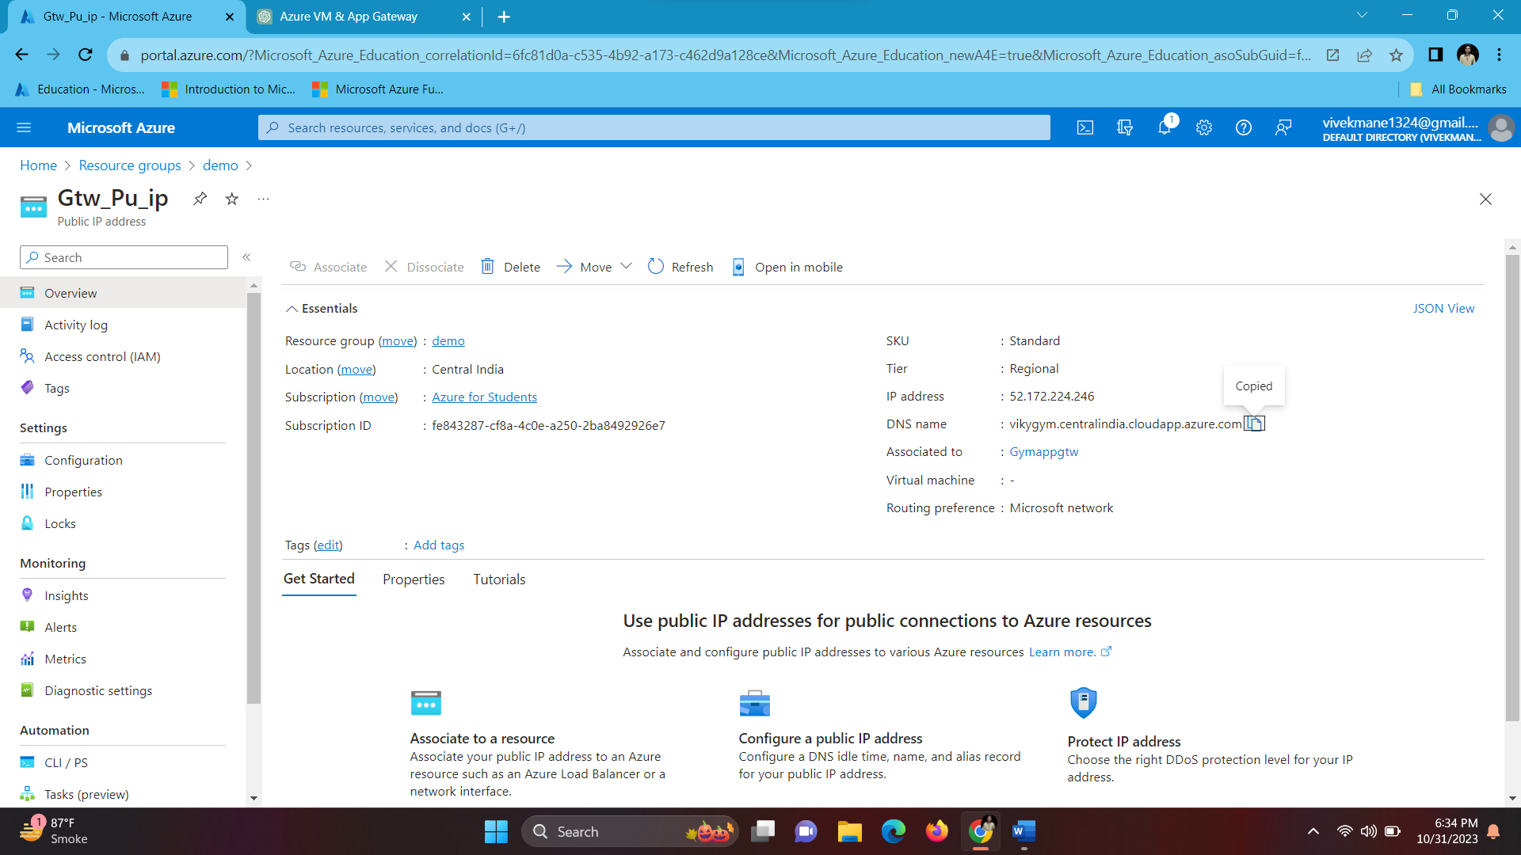

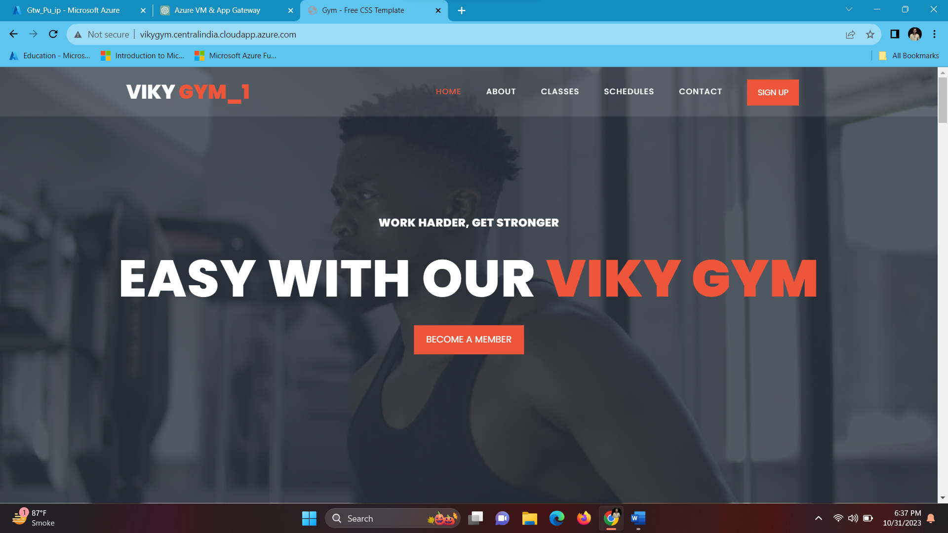

**Output Of This Website :**

This is the Home page of my web site

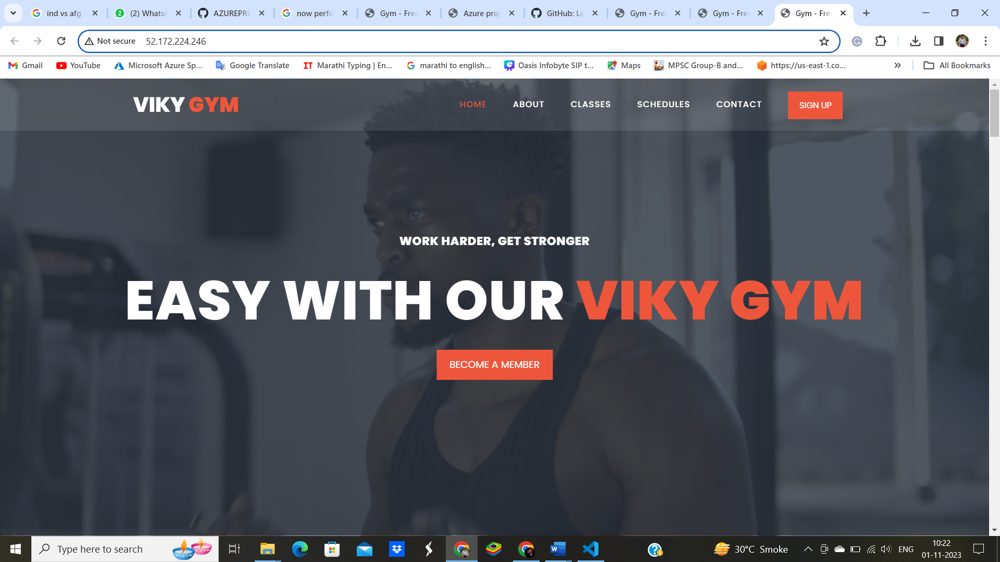

This is the About of VIKY GYM

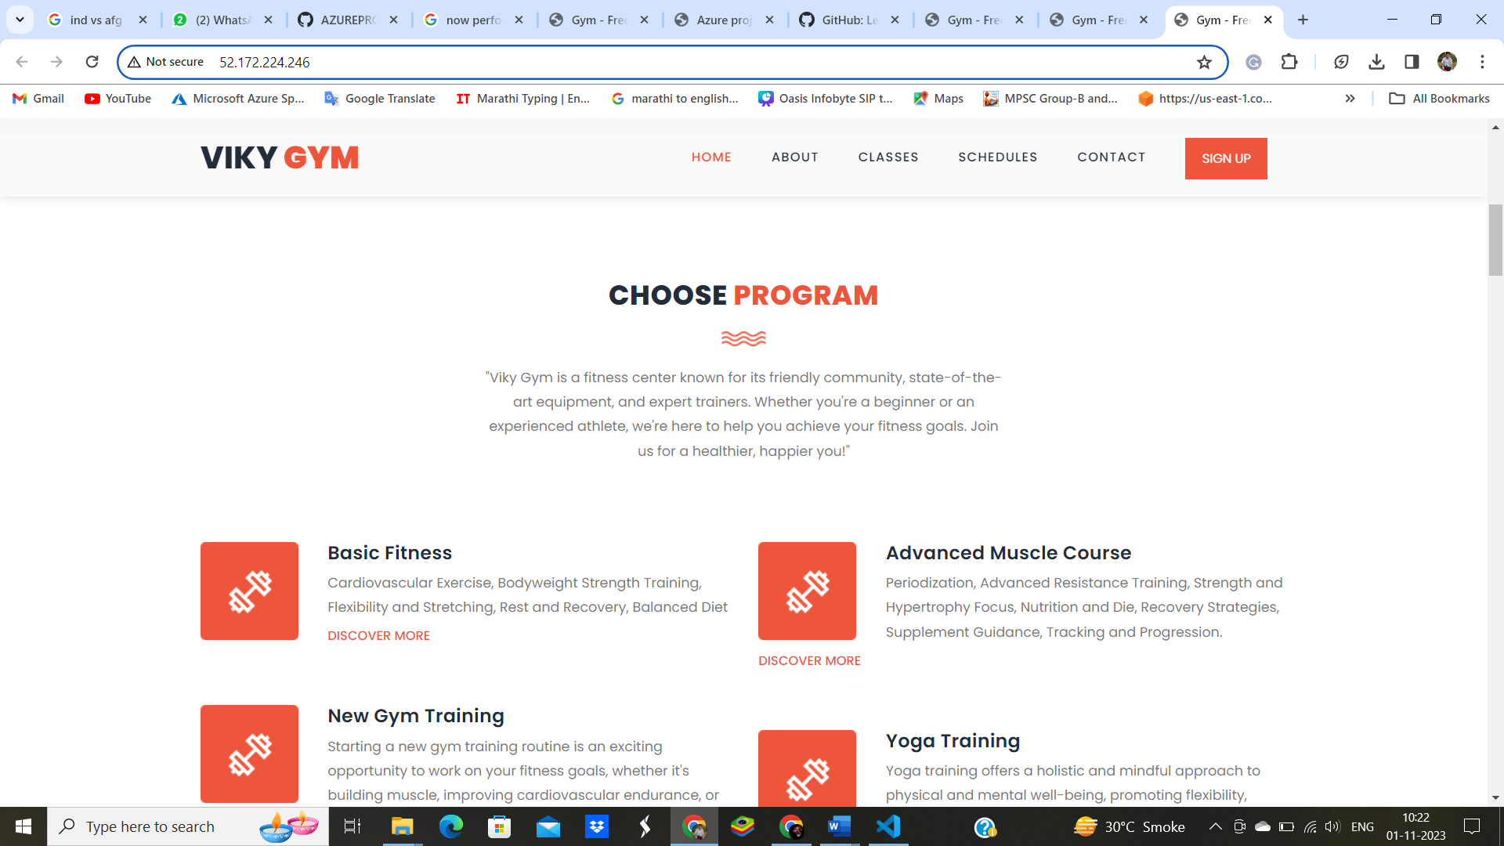

This is the CLASSIES of VIKY GYM

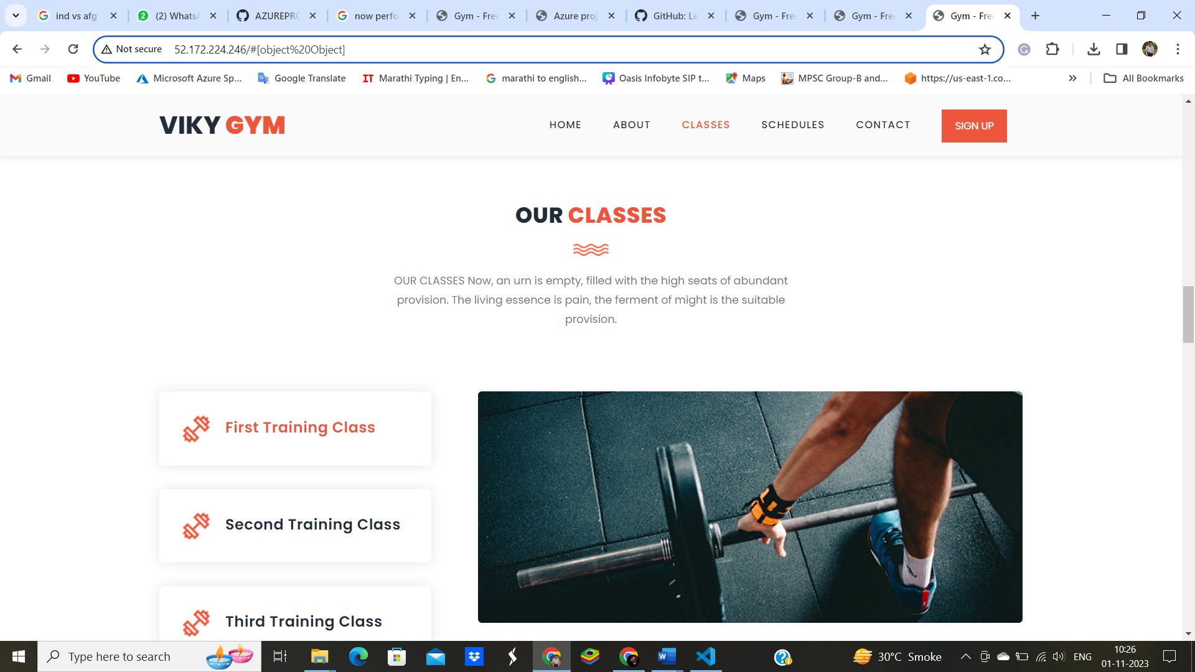

SCHEDULE Your Time for Training

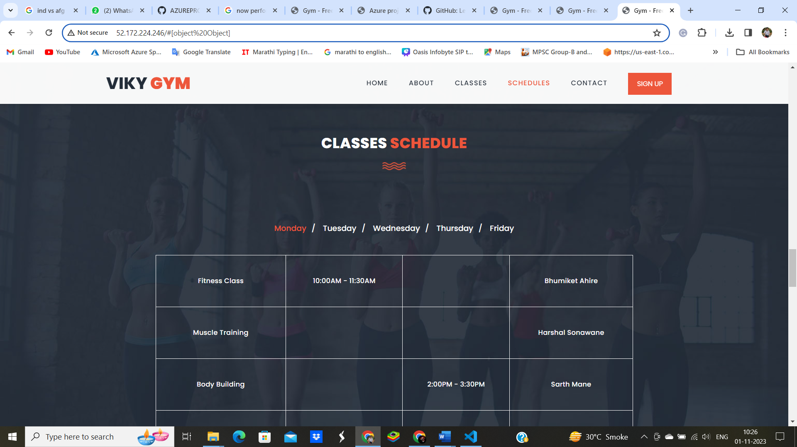

This Is The Gym Expert Trainers In Vikygym

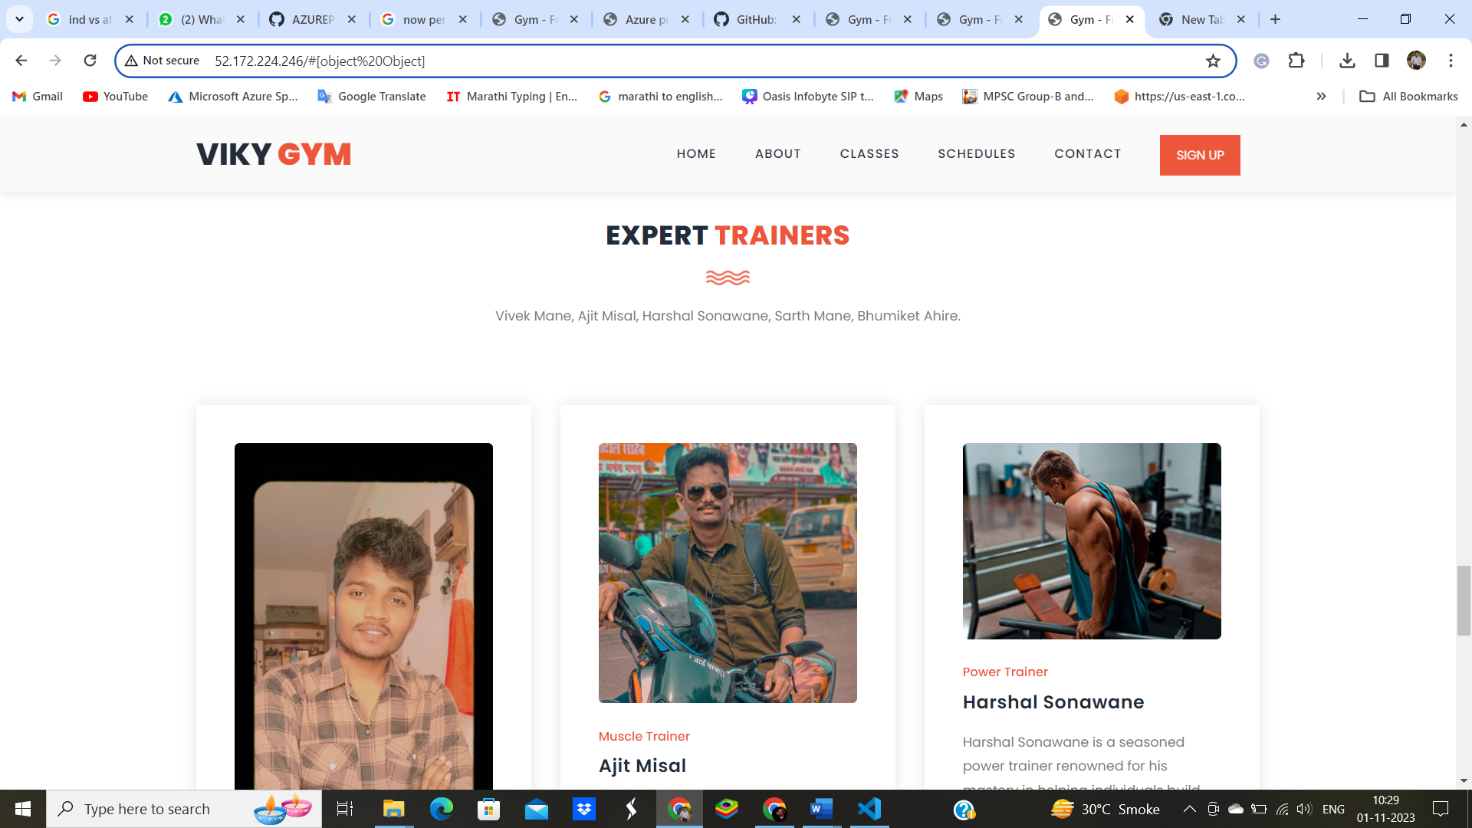

This Is The Contact Page To Easy To Contact With Experts And join The Gym, Schedule Your Time.

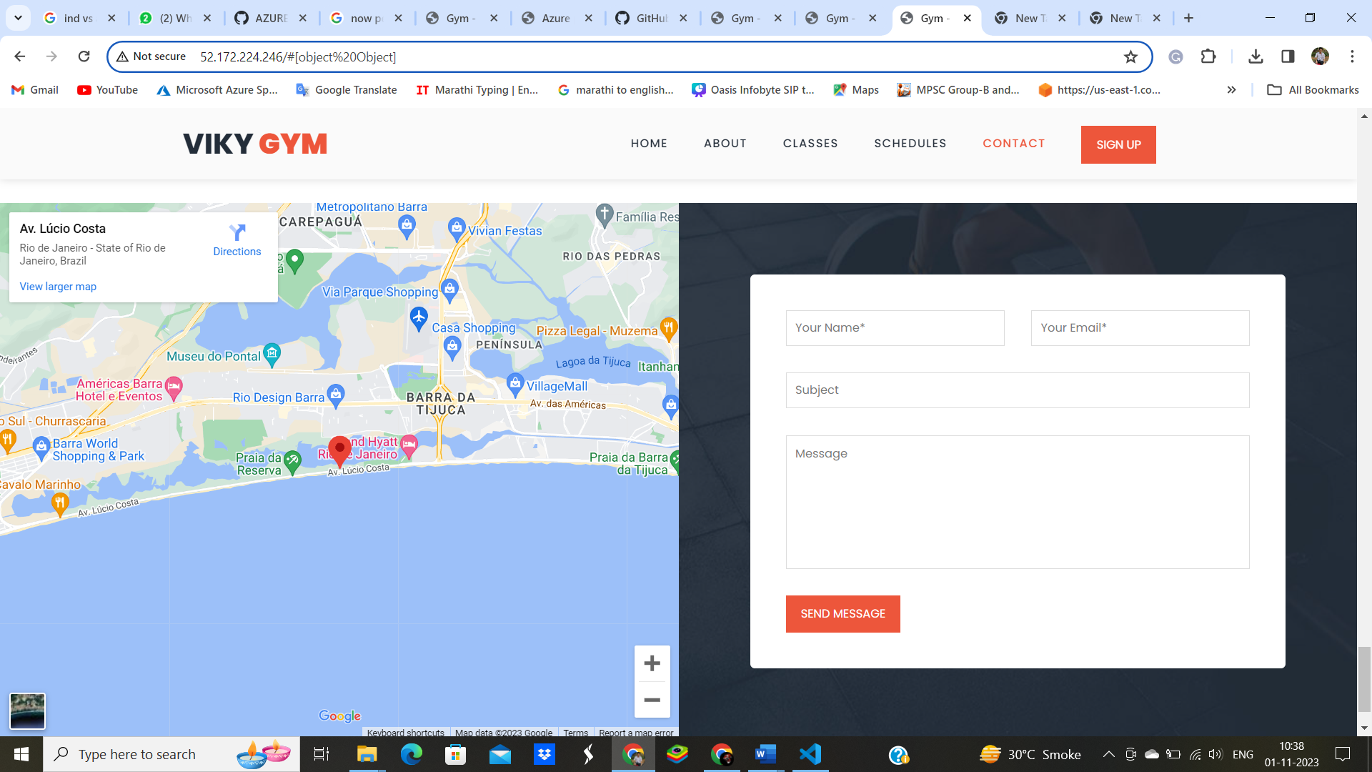

Thank You